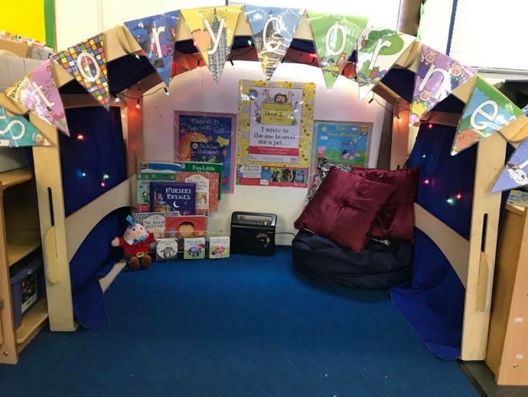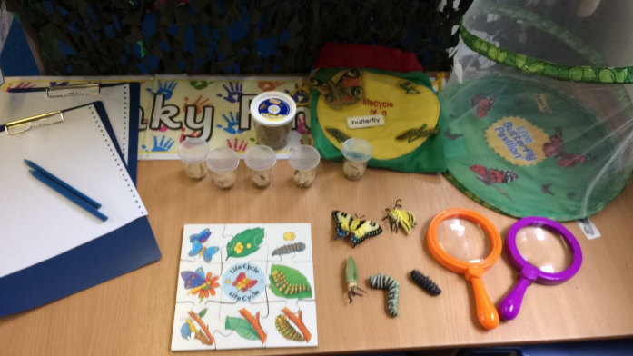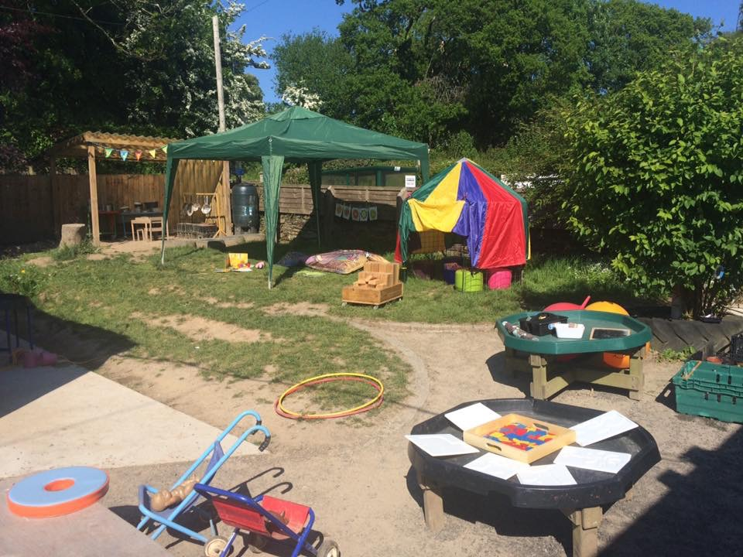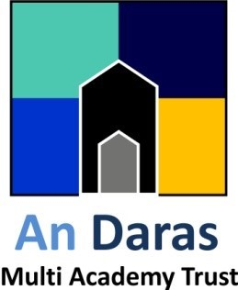

Flexible Childcare to suit your needs, Choose from our Session Times of:

Mon: 9:00-12:00 12:00-3:00 9:00-3:00

Tue: 9:00-12:00 12:00-3:00 9:00-3:00

Wed: 9:00-12:00 12:00-3:00 9:00-3:00

Thurs: 9:00-12:00 12:00-3:00 9:00-3:00

Fri: 9:00-12:00 12:00-3:00 9:00-3:00

St Stephens Community Academy

Roydon Road

Launceston

Cornwall

PL15 8HL

www.ststephenscornwall.co.uk

We currently have limited spaces available for Funded and Fee Paying 2-4 year olds.

Contact Marie for more information on

01566 777109

St Stephens

Pre-School