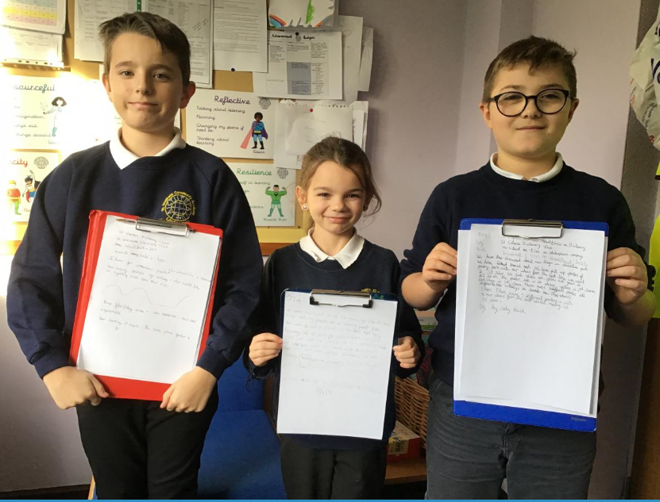
Today (17.1.2019) our representatives from the Pupil Forum attended their second Youth Council Meeting to discuss community issues. Today the agenda included what would be the best provision for children at Coronation Park. The equipment was discussed and our pupil Forum members, Cody, Mia and Maciej, now have to survey the rest of St Stephens to see which are the most popular ideas. These include a skate park, cycling path and new tunnels for climbing through. There is a £2, 600 budget for the schools to share. We have already confirmed finances for dictionaries and today it was confirmed money would be available for our Romeo and Juliet theatre company work at St. Stephens.
Thank you Pupil Forum for your responsible , mature attitudes - you are really demonstrating reciprocity by working together and Individual Liberty by collecting our views.

