Launceston – a local study
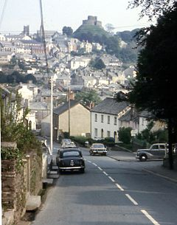
Launceston - geography
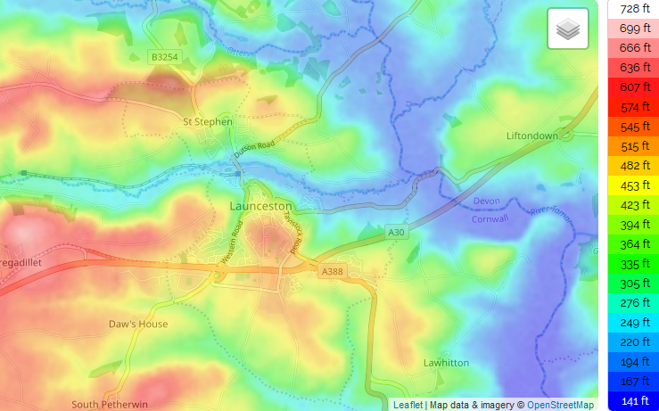
Launceston is a town, ancient borough, and civil parish in Cornwall – known as the ‘gateway to Cornwall’. It is one mile (1.6 km) west of the middle stage of the River Tamar, which constitutes almost the entire border between Cornwall and Devon. The landscape of the town is generally steep, particularly at a sharp south-western knoll- topped by Launceston Castle. These gradients fall down to the River Kensey and smaller tributaries.
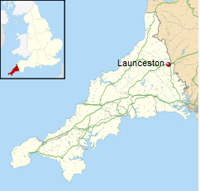
The Castle

A mighty Norman fortress looming over Launceston atop a natural mound. The castle was originally called Dunheved, and was built to control the crossing of the River Tamar in and out of Cornwall. In the 13th century Richard, Earl of Cornwall rebuilt the castle in stone, and fortified the central tower. The castle was used for many years as a court and gaol.

History
Shortly after the Norman Conquest, William the Conqueror made his half-brother, Robert of Mortain, the Earl of Cornwall. Earl Robert built a castle at Launceston, on the main transportation route between Cornwall and Devon. The castle was a traditional motte and bailey design favoured by the Normans, with a timber palisade atop a high mound, surrounded by an outer bailey enclosed by earthworks.
Launceston Castle served as the main administrative centre for the Earls of Cornwall. Sometime in the late 12th century, a circular stone keep was erected on top of the castle mound. Then in 1227 Robert, brother of Henry III, replaced the remaining Norman timber fortification with a strong stone castle, built a keep inside the circular tower, and erected a stone curtain wall in place of the earthwork banks and ditches.
Earl Richard enlarged the earlier hall, strengthened the curtain walls, and built a barbican to defend the south gate. The Earl also built a wall around the town and added three gatehouses for extra security. This made Launceston the only walled town in Cornwall, another indication of the town's importance. However, that importance was not to last, for when Earl Richard died, his son and heir, Edmund, moved his administrative centre to Lostwithiel, and Launceston Castle was allowed to decay.

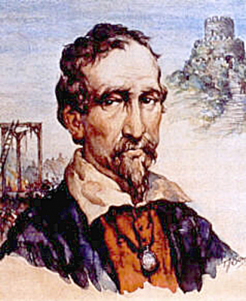
Elizabeth’s Prison – the death od Cuthbert Mayne

By the 16th century the medieval castle was falling to pieces, and though it was not used as an administrative centre, it still served as a prison. The most famous prisoner to be held in Launceston gaol was George Fox, founder of Quakerism. At least Fox was released after 8 months, unlike the Catholic Cuthbert Mayne, who was executed in 1577 for his religious views. In 1838 the county courts were moved to Bodmin and Launceston's prison was torn down a few years later.

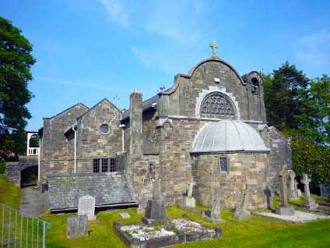

Compare maps of Launceston over time - notice settlement spread and change in town identity from a castle and battlement to a market town to a commuter location.

