**Leisure and entertainment in the 20th Century**

Changes in employment law 1939 meant that every working person was entitled to one week’s paid holiday per year. Many people had never taken a holiday before: this created a revolution for businesses that provided leisure pursuits and holidays. In 1900 an average working week was 54 hours, by the 1980s this had dropped to 39 hours.

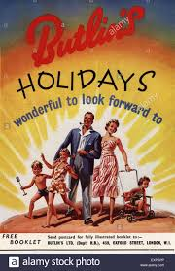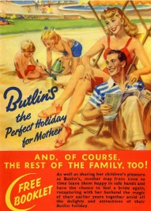

The 1960s decade is known as the Swinging Sixties and is associated with the birth of British pop music and fashion.

Events

* 1961 - **First man in space**
* 1966 - England won the football World cup
* 1969 - First humans to walk on the Moon

Population

* 1960 Population of Britain was about 53 million
* 1960 World's population was just over 3 billion.

Cost of items

* The average house price was £2,530
* Loaf of bread 5p
* A season ticket to see Manchester United cost £8.50.

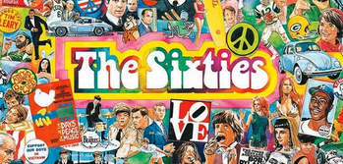

**BillyButlin** set up holiday camps for British families. His first was built at Ingoldmells, Skegness in 1936. Families provided with food, accommodation and entertainment all in one location.

**Oswald Stoll** was famous for creating theatre entertainment (the Royal Variety Performance) and establishing film studio production- popular in the silent film era.

**Oscar Deutsch** was the father of the Odeon cinema group. He bought British films and Hollywood movies to people in 258 locations across the country.

In the 20th century people started working less hours and free time became a lot more important. People began to have disposable income and businesses promoting ideas about how to spend that money started popping up. This was the rise of the Leisure Industry.