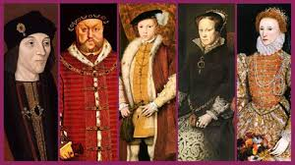
Y6 Changes in power – The Turbulent Tudors
reign | treason | heir | royal
war | religion | catholic | achieve
monarch | divorce | bloodline | conflict
survive | behead | alliance | abolish
controversy | symbol | persuade | military
Pope | Rome | determined | noble
succeed | guilty | council | necessary
legacy | church | succession | appease
opposition | support | execution | advise

