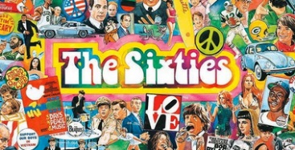
Y6 Leisure and entertainment in the 20th Century
leisure | advances | culture | craze | enhance | invite
provide | opportunity | design | disco | secure | exotic
theatre | revolution | purpose | flare | inspire | era
studio | function | desire | revive | entitle | wage
family | freedom | social | unity | popular | rebel
finance | technology | impact | modern | movement | trend
silent | industry | graphic | express | popular | film
gaming | behaviour | effect | affect | lifestyle | mono

