What are schemas and how do they influence our planning and provision?

Here at St Stephens Pre-School our staff are committed to building strong key person relationships with our key group children and their families, this enables us to get to know the children very well, find out what their interests are and if they are showing patterns of repeated behaviours.
These patterns of repeated behaviours are called schemas, our staff have a good understanding of schematic behaviours and we use this knowledge alongside regular observations to plan high quality, tailored provision that supports and extends the schema as well as following the child’s current interests. This type of planning promotes opportunities for a higher level of engagement which is when deeper learning can take place in a fun and playful way.

As a parent you may wonder why your child enjoys lining up their toys, hiding under tables or sitting in enclosed spaces, they may enjoy emptying and filling containers, the behaviours can often be seen as negative behaviour (emptying cupboards or hiding objects away) but they are extremely important stages in your child’s learning and development. By repeating these actions your child is making sense of the world around them and learning valuable new skills.
The following table describes the type of behaviour or repeated action that you may see and toys, resources and ideas that can be used at pre-school and in the home to develop and extend their schema.
We regularly observe the children our setting but also value parent input, if you do spot any of the patterns of behaviour, please do let us know so that we can also look for ways to extend the learning that is taking place.
 | Trajectory |  | 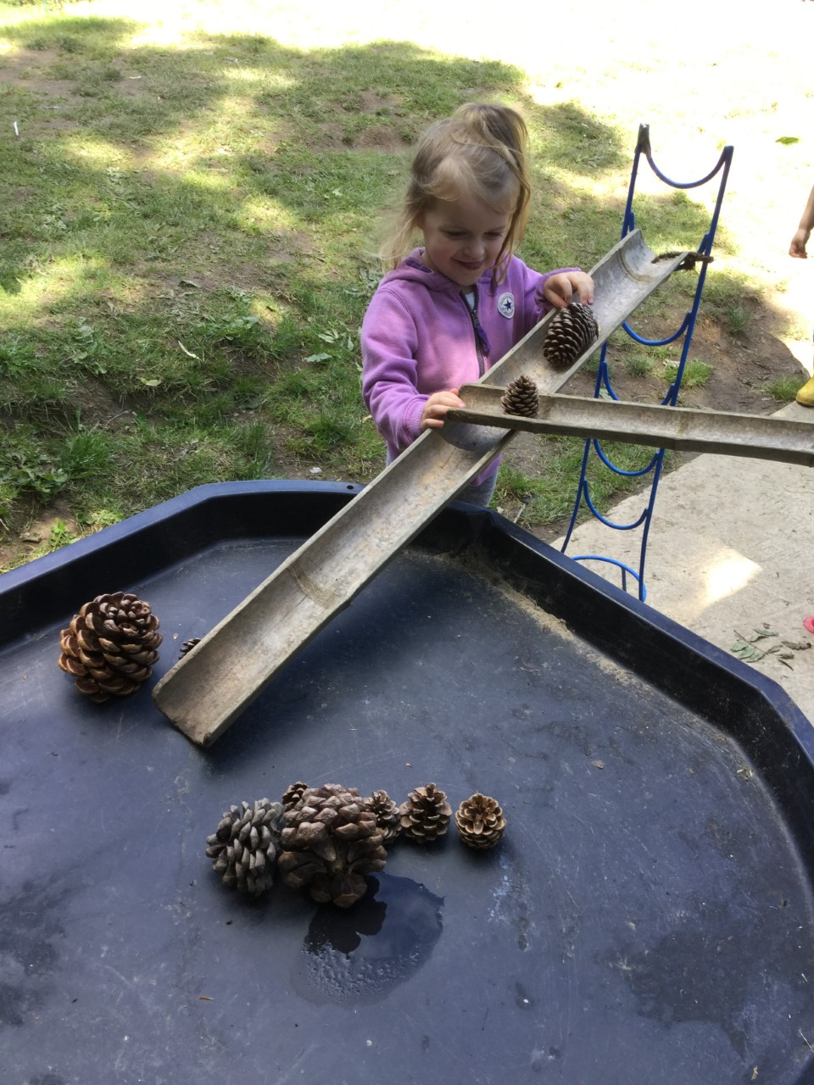
Example of behaviour |  | This could be diagonal, vertical or horizontal. Repeated behaviours include dropping items or food from cots, highchairs etc. Playing with running water from the tap, building and knocking down towers, climbing and jumping off furniture, throwing, bouncing or kicking balls.
Resources to provide |  | Provide a range of climbing resources at different heights with capes and material to jump with so they can learn about height, distance and develop gross motor skills, whilst having the opportunities to role play. Enable children to explore movement by allowing floor space indoors and time outdoors.

 | Rotation |  | 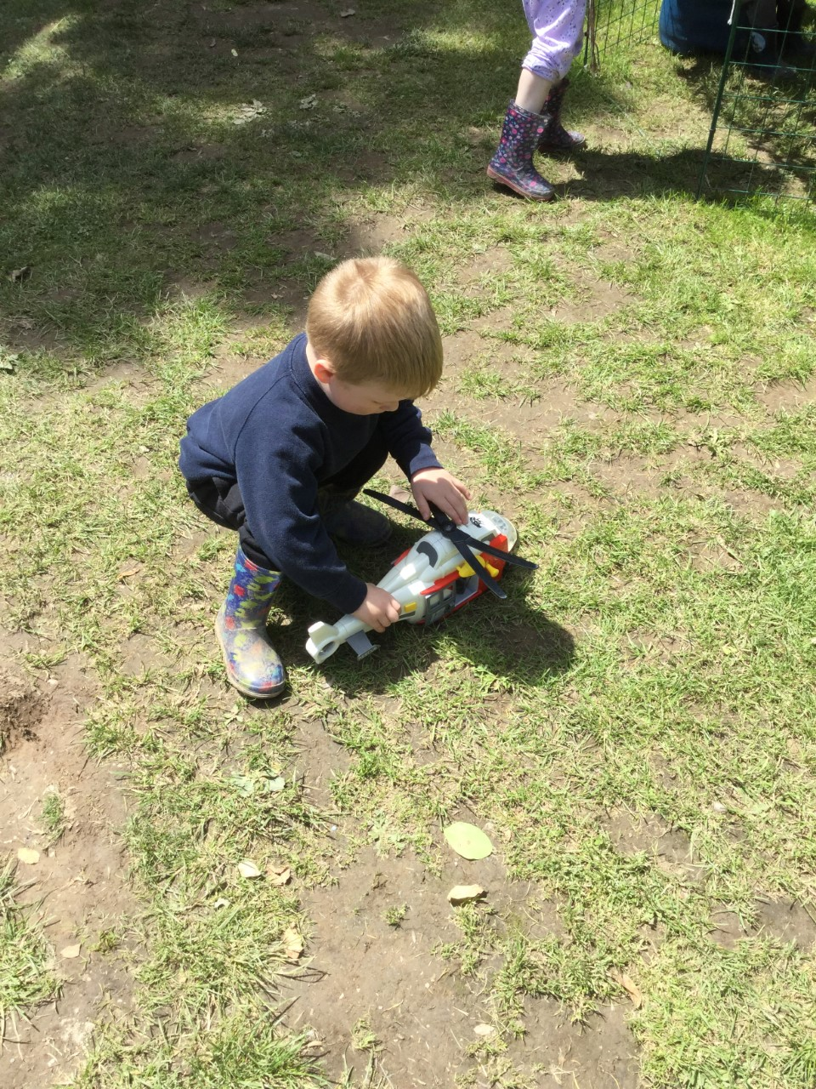
Example of behaviour |  | Anything that spins or rolls, children may enjoy watching the washing machine or rolling down the hill, some may spin around, ride on roundabouts or prefer round objects, and others may have repeated behaviour over wheeled toys including bicycle wheels.
Resources to provide |  | If a child displays this type of schema provide a wider range of round materials, including plastic bottles with lids, clocks, balls, wheeled toys.
 | Enveloping and containing |  | 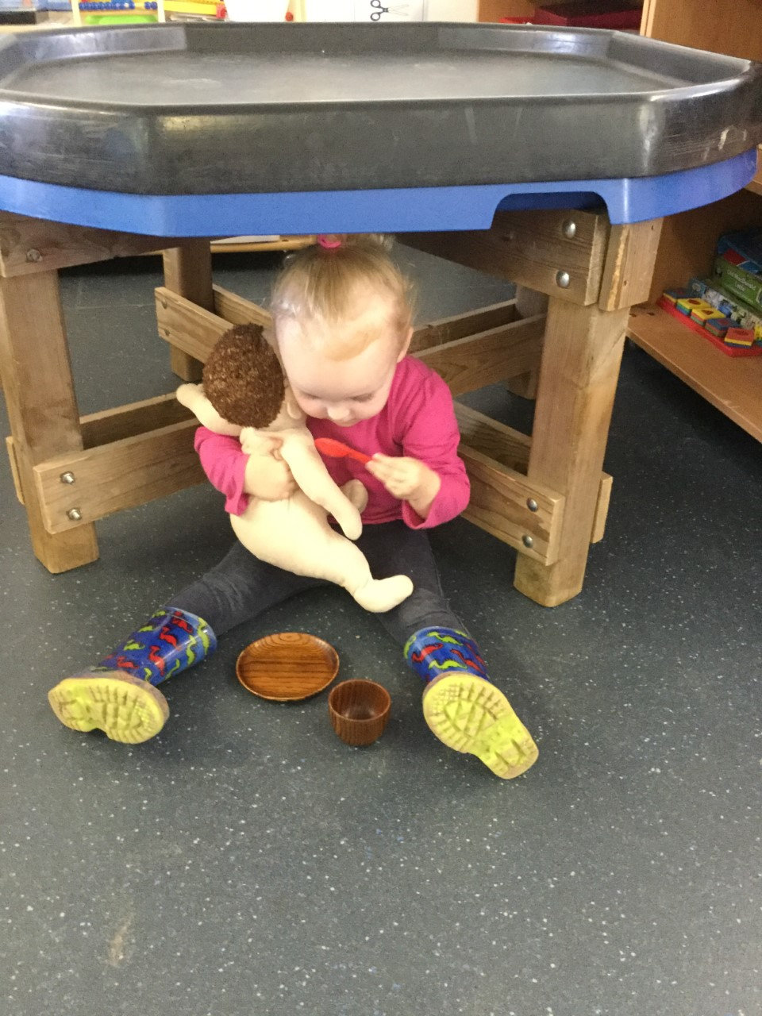
Example of behaviour |  | Children who develop this schema may like to hide in cupdoards, play under tables or be covered up; they may dress up in layers of clothing including hats. They might enjoy wrapping up dolls and teddy bears in blankets and/or play ‘peek a boo’ or ‘hide and seek’. This may also include filling and emptying lots of containers and/ or bags repeatedly, e.g. placing items in the bin.
Resources to provide |  | A child who develops this schema needs to have a range of materials and dressing up clothes to envelop in. The more different fabrics and materials the better.

 | Transporting |  | 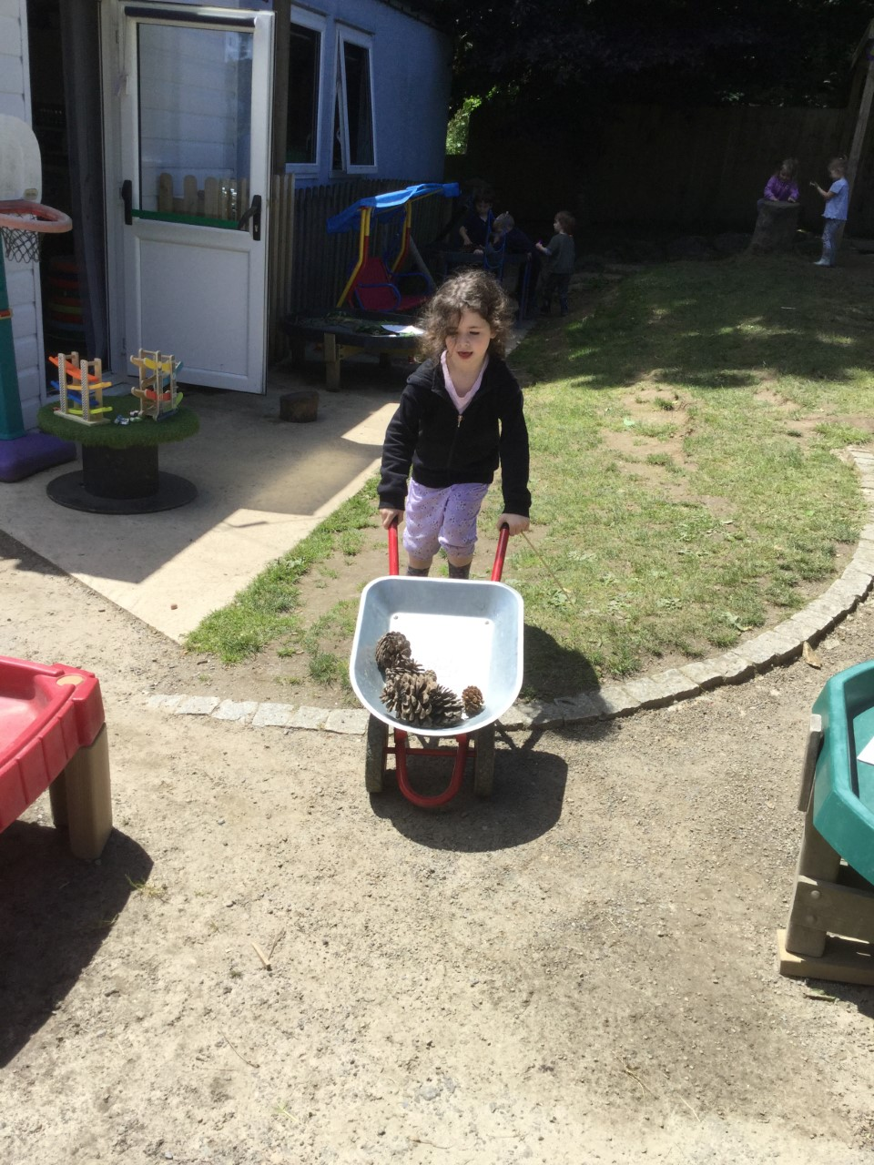
Example of behaviour |  | This is when children move objects from one area to another, sometimes with their hands, in bags or via dolls prams or trolleys. They may like to push their friends around in pushchairs or transport sand/ water from one area to another.
Resources to provide |  | Supporting this schema involves having a wide range of wheeled toys, e.g. pushchairs, trolleys and bags, baskets etc. so children can move equipment from one place to another freely. Often children like to move sand from one place to another, which can become quite frustrating for those who then have to clean it up. Providing buckets around the room for children to fill can support this schema rather than them just putting it on the floor
 | Connection |  | 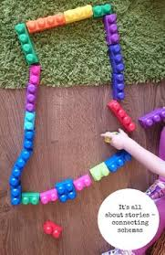
Example of behaviour |  | Children will join or connect materials or objects together; this may include connecting the train track together, trucks or using any type of tape, string or bands to connect materials. Outdoors they may spend time transporting guttering or planks and use string to connect these together.
Resources to provide |  | Children who show connecting schemas often spend extended periods of times at the  ‘workshop’ table, there should be a range of materials for children to join and connect materials including scissors, tape, glue, spreaders, masking tape, staplers, string and elastic bands. They should also be  encouraged to explore this more widely e.g. in the construction area taping structures together etc. Outdoors children should be able to explore and connect guttering, piping, planks and have access to water and / or sand to transport along the structures. A range of construction materials should be provided that enable children to connect pieces together including, train track pieces and other resources that connect together.

 | Enclosing
Example of behaviour |  | Children usual display behaviours such as climbing in to boxes, tunnels or pop up houses (anything where they are covered). They may also draw boarders around their mark making. Emptying and filling boxes can also come under this or constructing enclosures around them or small world animals with bricks or other equipment. | 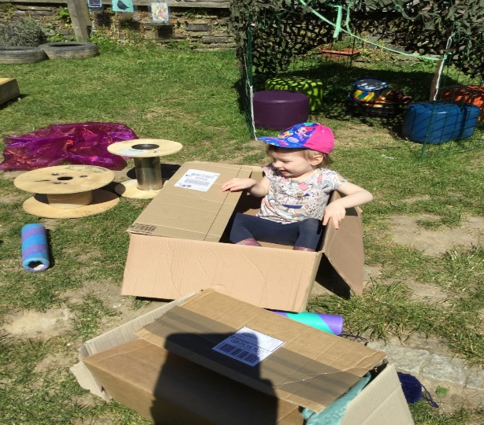
Resources to provide |  | To support a child’s enclosing schema practitioners should provide materials such as a range of different sized bricks, train tracks cardboard boxes and/or pop up tents so children can make enclosures around them. Providing small bricks and other similar resources with small world animals, vehicles or small people can enable children to have the opportunity to build fences/walls around those.

 | Transforming |  | 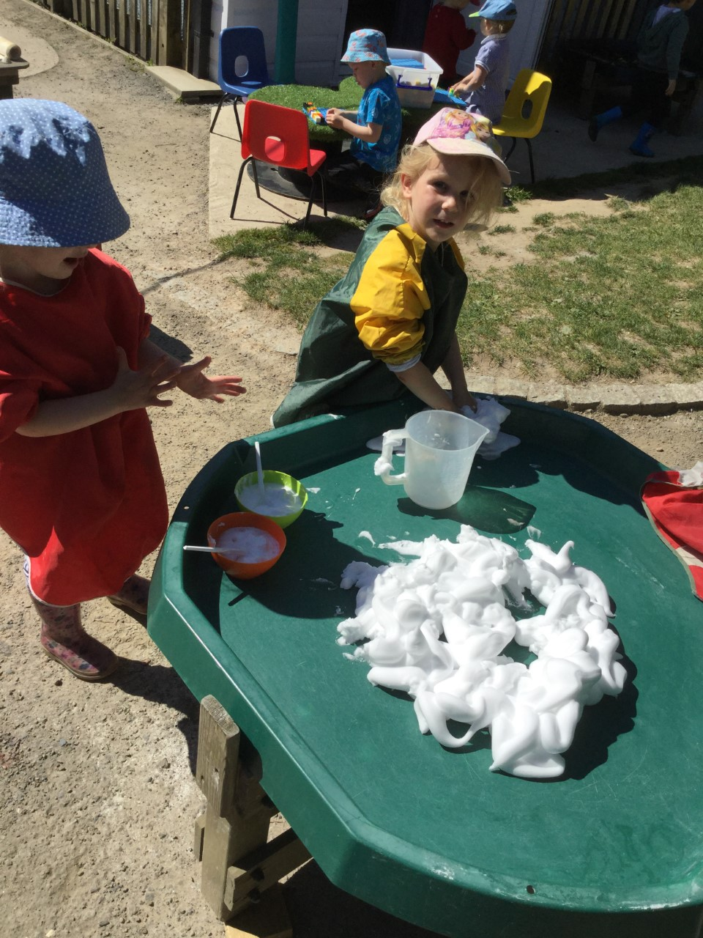
Example of behaviour |  | This schema is when children like to explore and see changes, e.g. adding colour to cornflour, mixing paints together, making or manipulating playdough, adding juice to food to see what happens, adding water to sand and/or making sand moulds.
Resources to provide |  | Children who display this schema need lots of opportunities to explore malleable materials, giving them time and resources to see changes and different tools, for example letting children make the play dough from scratch and mix paints rather than having it ready made, enabling them to add colour to corn flour or water to the sand. Enabling children to just mix paints together or paint their hands and observe this rather than asking them to paint a picture supports the child’s interest. Having resources within easy access where possible for children to choose would enable them to play with for example, sand mounds when they want them rather than having to wait for a certain day in the week.

