WHAT IS BIKEABILITY? Bikeability is the national cycle training programme supported and funded by the Department for Transport. The course builds the skills and confidence of children who can already ride. Bikeability cannot only make children better cyclists; potentially for the rest of their lives but can help with general confidence and independent thinking. All of our Bikeability training is delivered by qualified, professional, DBS checked National Standard Instructors. Visit www.bikeability.org.uk for more information

Covid-19: The Bikeability delivery guides that all registered Bikeability providers and instructors must follow were updated on 17th May 2021 in line with current government guidance for schools on implementing Covid-19 protective measures issued on 17th May 2021.
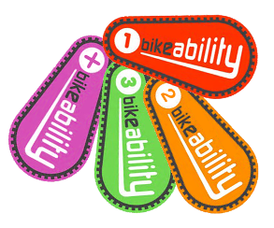 | The Bikeability Learn to Ride module is for both adults and children who are unable to cycle. Sessions will be taught in small groups, in a pressure free environment, by Scheme staff and targets those struggling to master the skill, children who are ready to make the move to riding with pedals after Bikeability Balance or adults who have never learnt to cycle. The aims of the Bikeability Learn to Ride module are:  - More children able to cycle, thus more children cycling into adulthood overall.  - More adults cycling - increases normalisation of cycling and leads to more families/children cycling  - Accelerate learning of very confident/competent younger trainees after Bikeability Balance

COURSE INFORMATION | WHAT WILL YOUR CHILD NEED?
Bikeability Learn To Ride  Number of sessions – 1 /2  Dates – 2023/24  Year groups – Yr4 and Yr 6  Timing – w/c 25th September  Cost – None | - A complete consent form (see section overleaf)  - A roadworthy bike without stabilisers  (see checklist overleaf)  - A helmet if required  - Suitable clothing for the weather conditions

FURTHER INFORMATION FOR PARENTS This course develops the cycling skills and confidence of children who cannot cycle. To benefit from Bikeability, your child must attend every session and practise what they learn after training. Bikeability skills and confidence will be lost without regular cycling. Bikeability engenders enthusiasm while building skills and confidence to cycle more safely, more often. Please support and encourage your child to continue cycling after training.

HOW TO BOOK Bikeability places are limited and places will be booked on a first come basis. Please complete and return a consent form (see overleaf) to school as soon as possible.

GET READY (Visit bikeability.org.uk/bikeability-training/get-ready/ for more information) Before your course it is really important to have a few things sorted including:

Your bike - make sure you check that your bike is in good working order, with the tyres inflated and the moving parts working well. If you need to take it to a bike shop before-hand, don’t leave it to the last minute!

Your helmet - your helmet should sit on top of your head comfortably, (not too tight or too loose), with the peak sitting about two fingers width from your eyebrows. The side adjusters should sit just below your ears forming a nice V on the side of your head, and the chin strap should allow for two fingers to fit between it and your chin.

Your clothing - wear whatever you would normally wear to school, but you must also be prepared for the weather. On cold or wet days, make sure that you have your coat and gloves, and an extra layer or two. With a change of clothes available, just in case. On warm sunny days make sure you have put on a good amount of sun cream at the start of the day and keep drinking water throughout the day. And a top tip – as you will be using a bit more energy than normal bring an extra snack, also making sure you’ve had a good breakfast before school.

Your feedback – please CLICK HERE to complete our course feedback form following your child’s course

PRE-COURSE BIKE SAFETY CHECK
Visit bikeability.org.uk/bikeability-training/get-ready/

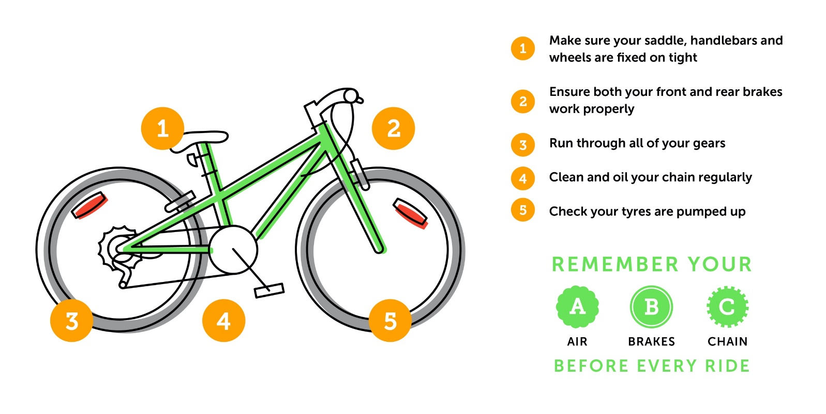

PARENT/CARER - Please read the following information before completing and returning the consent slip to your child’s school. I understand that:
- I agree to my son/daughter taking part in cycle training
- My son/daughter cannot ride a bike without stabilisers
- The instructors may refuse to train my child if they deem his/her cycle to be un-roadworthy
- It remains my responsibility to ensure my child does not ride an un-roadworthy bike and if I am in doubt as to whether a cycle is roadworthy I should seek the advice of a professional mechanic
- Instructors may at any time refuse to continue to train my child if his/her behaviour deemed unsuitable
- Arena will not be responsible for any injury or disease transmission or liable for any loss or damage to participant’s cycles and other belongings
- I agree for my child to wear a helmet, which I will provide
- I consent to the Bikeability instructor ‘adjusting’ my child’s helmet if required, however I confirm they are not responsible for the physical condition or appropriate fitting of the helmet
- I understand that pupil data collected will be used to support the delivery and monitoring of training sessions/courses, see bikeability.org.uk/privacy-statement/ for further details.
- I agree to encourage my child to practice between each session and after the completion of training

Full Name of Child:
School:
School Year:
Are there any medical/educational needs we need to be aware of, including allergy to hand sanitiser?
Is your child ‘clinically vulnerable’ and at ‘moderate risk’ from Covid-19 according to current NHS guidance?
Does your child live with someone who is ‘clinically vulnerable’ or ‘clinically extremely vulnerable’ from Covid-19 according to current NHS guidance?

If you are happy for your child to be photographed and/or filmed to help promote Bikeability, please tick here

I confirm that I have read all the information enclosed and in the ‘Parental Consent Form’ and consent to my child (or the above child for whom I take responsibility) to take cycling lessons and related activities, which may include cycle maintenance as well as riding on the public highway. I understand that this information is retained by my child’s school and used to ensure my child is eligible to undertake Bikeability training

Signed (parent/guardian) :
Date:

