Welcome to Y4

We are Mrs Hunt and Miss Callcut, we will be teaching you in Year 4. Miss Bebbington will be also joining us every morning.
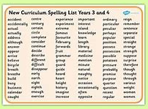
Like in Year 3, we will start the day with Spelling and Guided Reading. We will work on common spelling rules and patterns in Spelling, and in Guided Reading we will share whole texts- analysing its structure, content and purpose.

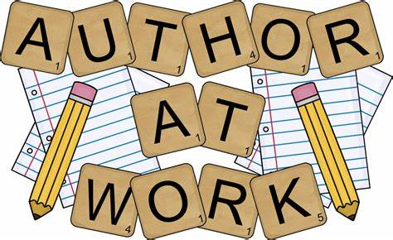
After these, we have our English learning. We look at lots of different text types in Year 4, including: stories, information texts, letters, instructions, reports and poems We use these examples to help us create our own versions, using our own ideas. On our tables and around the room, we have lots of materials to help us with our writing.

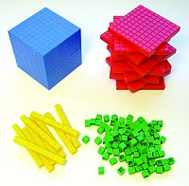
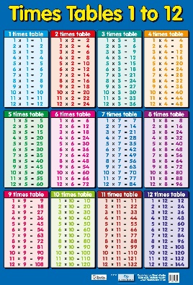
After break, we have Maths. Times tables are a key focus and we will be working hard to know these by heart. Maths learning will follow a similar structure to that of Year 3 with lots of fluency and problem solving to test our understanding. Again, there will be lots of practical resources to help you.

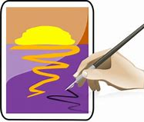
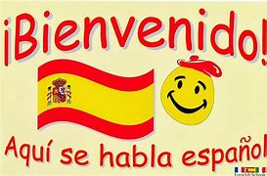
On a Monday afternoon (with Miss Callcut) we will be doing lots of artwork, learning Spanish and exploring issues raised in SMSC. Art will focus firstly on drawing, then painting and finally – in the summer term- on 3D and printing. Spanish will pick up from where you got to before lockdown in Year 3 and SMSC will follow weekly Picture News topics of conversation.

Our Tuesday to Friday afternoons will follow our theme and a knowledge organiser will come out at the beginning of each new theme. Our first one will be Edinburgh. You will also have a key vocabulary list to support your learning. Each theme will start and end with a quiz so you can see your progress. We will also have P.E and music sessions with Mrs Hunt, Argyle, Arena and Mrs Gilbert. Home learning will be set alongside each theme and will need to be handed in every Wednesday. These include English, Maths and Theme related activities.

