This week’s art challenge:
A desert tortoise

This week I let my son, Theo who is in Y2, choose what to draw. He chose a desert tortoise – at least it is not another shark! There are steps to follow in the photos below… remember to keep the pencil lines light until you have the shape and proportion you want – then go darker with shading tones of grey. I look forward to seeing your tortoises
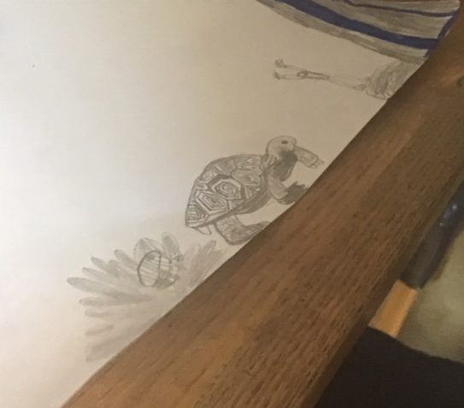

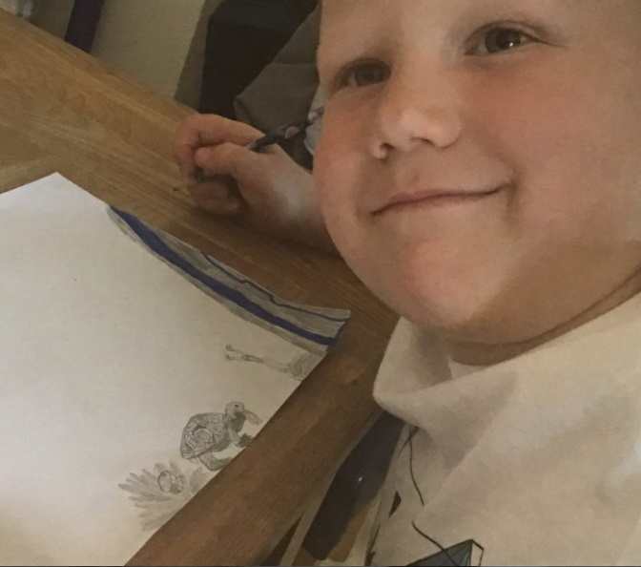

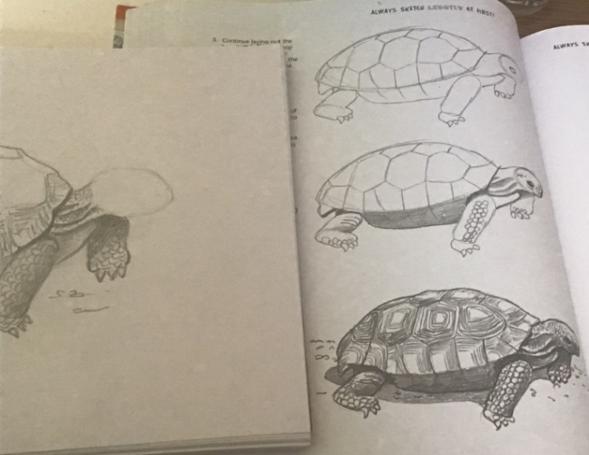
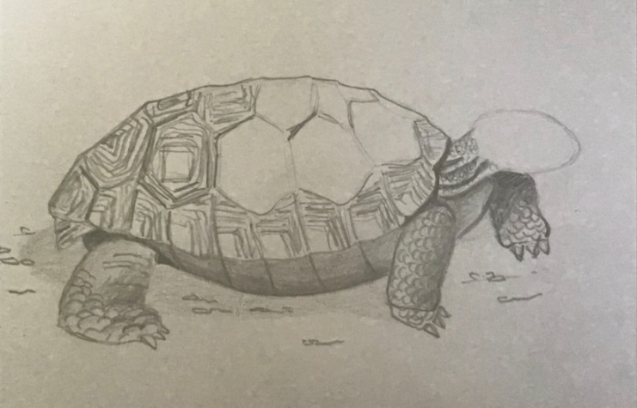
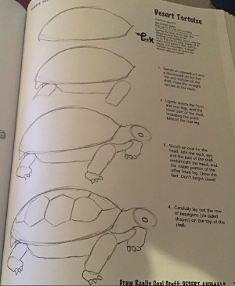

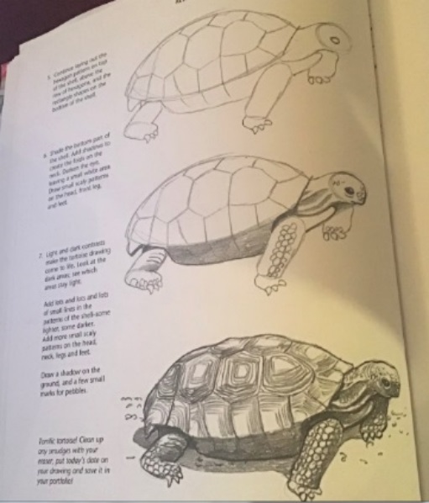

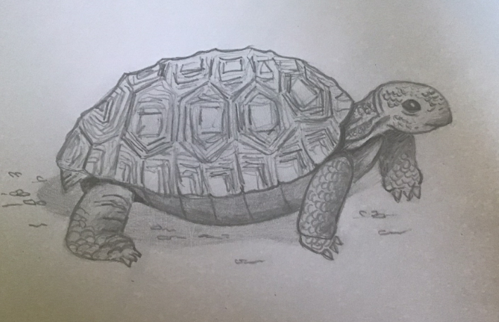

If there is anything you would like to put forward as an idea for an art challenge, please post your picture and a message to tell me what you would like to have a go at. We could try cartoon drawing… but of what? Have fun Miss C

