This week’s Art Challenge – set by Amber (Y4) A world of buildings
This week Amber has asked for ideas on how to draw buildings. It isn’t just when we are drawing landscapes that we include buildings, but also when we are drawing a scene with some of our favourite characters in it. We often want them in the background to add depth to our pictures. I hope these tutorials help – we look forward to your buildings Miss Callcut and Amber. I think I am going to try a cottage!?
Next week: Tyler’s Harpy Eagle challenge
Please upload to J2E so that I can put them on our new Art Gallery page.

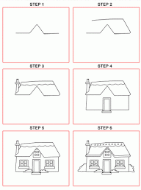
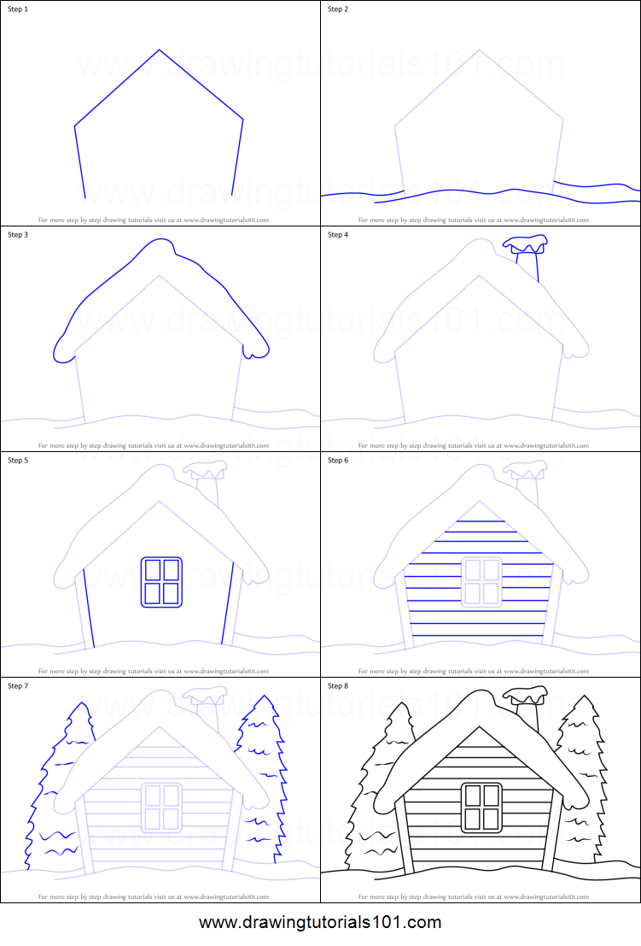
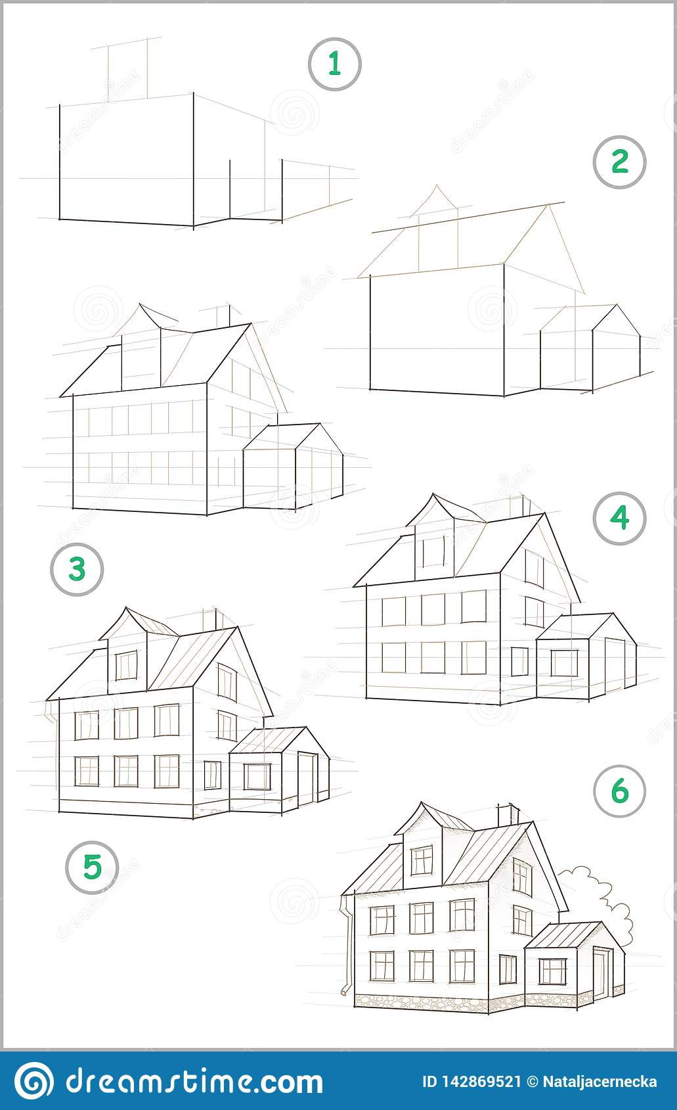 Sometimes the internet tutorials may be better

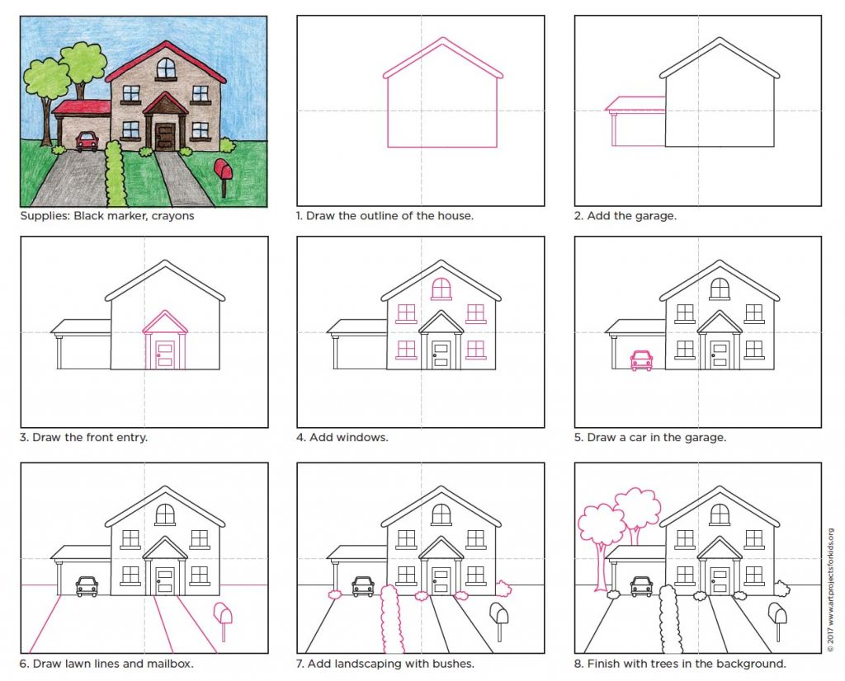
Useful websites: Easier:
https://www.youtube.com/watch?v=EMqUE_f-m4M
https://www.youtube.com/watch?v=LWIvQAWK-ww
https://www.youtube.com/watch?v=HHYNopeRihA
https://www.youtube.com/watch?v=opXUQ7kOkWs
https://www.youtube.com/watch?v=4zvSxGkAlLc
Watch the next two cityscapes in order:
https://www.youtube.com/watch?v=L-LIn7r9r1E
https://www.youtube.com/watch?v=moSYDq52IyY
More advanced- perspective:
https://www.youtube.com/watch?v=i776k0zEzEc
https://www.youtube.com/watch?v=mE1v-ALAmrA
https://www.youtube.com/watch?v=VyXmcj6DWe0

