St Stephens Community Academy

“Embracing Learning; Inspiring Ambition; Celebrating Individuality.”

Learning overview Theme: Community and Inheritance

Year - 2 AUTUMN TERM 2025

Community and Inheritance
Our learning theme this term is ‘Community and Inheritance’. We will be learning about the weather; both where we live and around the world. We will also be exploring important historical figures and their achievements.
Reflectiveness, Resourcefulness, Resilience, Reciprocity
We will be further developing their understanding of these learning skills in order to become more efficient, independent and proactive learners. A particular focus will be on developing active and appropriate listening and talking skills through a range of games and activities and being able to articulate what we have learnt not what activity we have taken part in.
PSED | We will be focusing on discussing and creating our class charter, developing confidence in expressing our opinions in front of our peers, discussing and understanding the importance of being safe, expressing our feelings in relation to ‘the learning pit’ and working together as part of a team. We will also be exploring and discussing different emotions and recognising when we are not happy and why, and what we can do to make ourselves and others feel better. We will be using ‘Ruby’s Worry’ and ‘The Colour Monster’ texts to discuss our emotions.
How to help | - Talk about different feelings and emotions.  - Discuss the importance of sharing any worries or concerns with an adult you feel safe to talk to.
English | We will be using the text ‘The Bear under the Stairs’ to start the Autumn term for our writing. This book, by Helen Cooper, is all about overcoming fears and the outcome of the unit will be to create an information text about bears.  Initially we will be focusing on demarcating sentences with capital letters and full stops, as well as types of sentences and corresponding punctuation - such as using question marks when required. We will also concentrate on using conjunctions such as or/and/but/when/if/that/because. In spelling we will be supporting the children to segment spoken words into phonemes (single sounds) and represent these by graphemes (letters), spelling many of these words correctly. In handwriting we will be focusing on the formation of capital letters and digits of the correct size, orientation and relationship to one another and to lower-case letters.  With both reading and writing we will continue to develop our knowledge of phonics and those tricky common exception words.
How to help | - Reading with your child daily.  - Practising the Year 2 common exception words.  - Practising letter formation.
Maths | We will be learning how to read and write numbers to at least 100 in numerals and in words, along with to recognise the place value of each digit in a two digit number (tens, ones). We will be able to identify, represent and estimate numbers using different representations including the number line and compare and order numbers from 0 up to 100; use <, > and = signs. We will develop how to use place value and number facts to solve problems, as well as to count in steps of 2, 3 and 5 from 0, and in tens from any number, forwards and backwards.
How to help | - Practise number formation.  - Practise ordering numbers within 100.  - Explore counting forwards and backwards in 10s from any number.  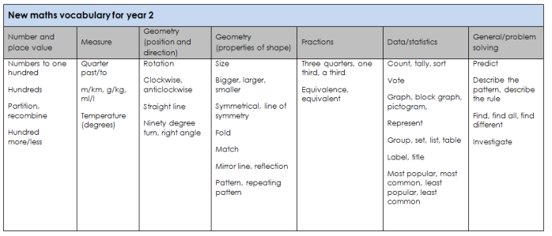
Science | In our science learning we will be exploring properties of everyday materials. This will also include how materials can provide protection from the weather; hot, cold and waterproof. We will be using our outdoor learning time to further enable the children to conduct their own experiments when exploring materials.
How to help | - Discuss recyclable and non-recyclable materials.  - Ask your child to assist with sorting the recycling at home.
Physical Development | We will be focussing on fundamental multi-skills as well as dance in the first half of the term. In dance we will be focussing on movement and sequencing a series of movements. We will also be discussing the importance of exercise and the effects it has on our body.
How to help | - Practise simple balances.  - Practise throwing and catching – you could start with a larger ball and then move to a smaller ball.  - Discuss the importance of keeping active and healthy.
Creative Arts/DT | We will begin drawing and developing our observational drawing skills. We will be exploring artwork by Vincent Van Gogh. We will evaluate and analyse our learning.  In DT we will be focussing on textiles and joining materials together. We will be designing, creating and analysing puppets.
How to help | - Discuss and explore drawing what you can see – you could use a mirror to focus on different facial features.  - Talk about what your child is proud of and wants to improve next time.  - Have another go!
Humanities | In geography we will be comparing hot and cold climates and extreme weather. This will link with our learning on materials. In history, we will be discussing events beyond living memory and the life of a significant individual; Guy Fawkes.
How to help | - Use a map or a globe to locate the continents.  - Discuss the story of the Gunpowder plot.
Notes for Parents:
Key vocabulary mats and knowledge organisers sent home, can also be found on our class information page.
Home learning – a new home learning sheet will be sent out in line with each new learning theme, this can also be found on our class information page. Home learning can be completed in the home learning book and is to be handed in by Wednesday, I will then feedback and return this on Friday. PE and wild tribe – please can children have their P.E kits and wild tribe kits in school every day.
Reading books – Reading books will be sent home in line with your child’s phonics group for the children to read and re-read throughout the week to build fluency. This will be for 3-5 days at a time depending on the teaching sequence. Reading can be recorded in the reading records which will be checked on a Friday – this can include school reading books and additional books read at home. Children will select a library book on a Friday to share with you over the weekend.

