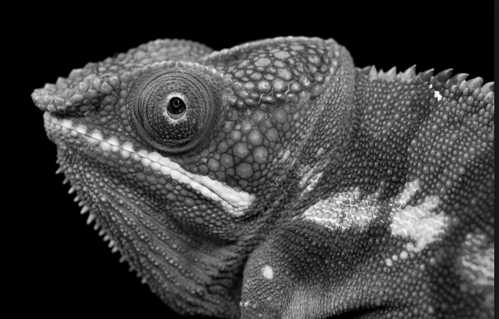
classification,
kingdom,
phylum,
class,
order,
family,
genus,
species,
Linnaeus,
opinion,
similarities,
adapt
differences
group,
observations
support
refute
branching classification key
Amphibians
Annelid
Arachnid
Bird
Crustaceans
Insect
Invertebrate
Mammal
Microorganism
Reptile
Vertebrate
fungi
bacteria
hygiene
habitat
biomes

