This week’s Art Challenge – set by Olly (Y3) A Lion
This week Olly has asked for ideas on how to draw a lion…one of my favourites to draw I have to say! Happy drawing everyone! Miss Callcut and Olly
Next week: Cody’s Panda challenge
Please upload to J2E so that I can put them on your class blog
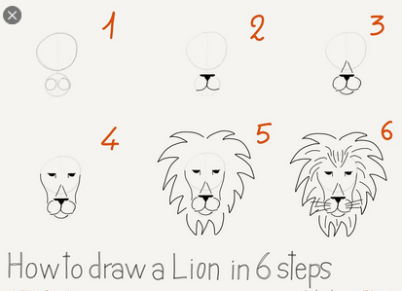
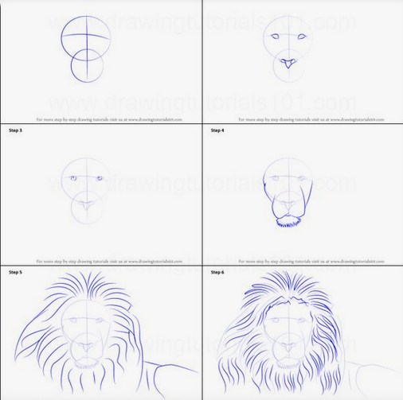
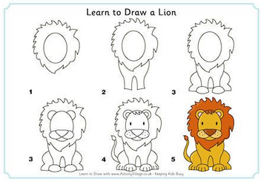
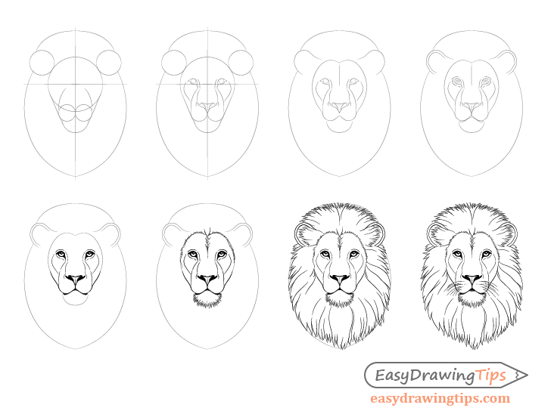
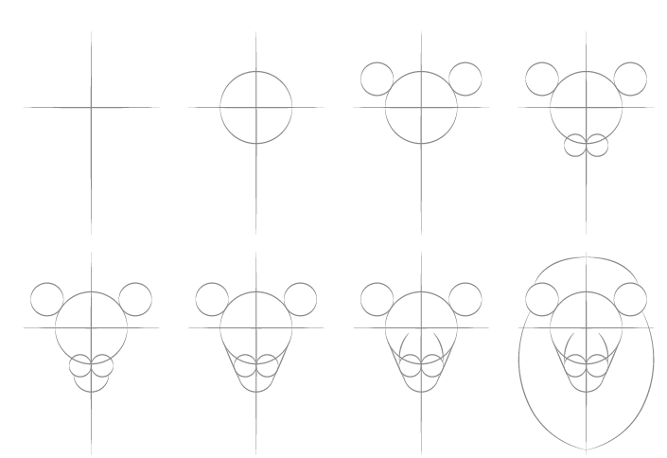

Useful websites:
https://www.easydrawingtips.com/how-to-draw-lion-face-head-step-by-step/

