VE Day Art Ideas

On the very special 75th Anniversary of V E Day I thought I would post some art ideas for you to have a go at.
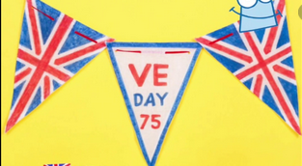
As well as traditional bunting, you could also try to make some other forms of art. Below are just some ideas, although many more can be found online – I would love to see whatever you decide to do. Have fun Miss Callcut
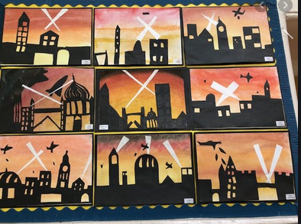
You could try a silhouette picture.
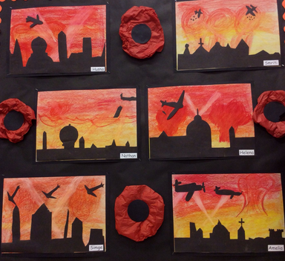
Paint or colour (with crayons) the background first and let it dry if painted.
Next you can either paint your ideas on in black or cut them out of some black paper and stick them on to the background.
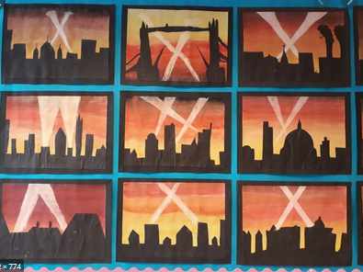
A variation could be dark seawater colour on the bottom half of the page and apply silhouette shapes of battle ships as well as spitfires in the sky – My grandads were both in the Navy during the war, so I may have a go at this one!

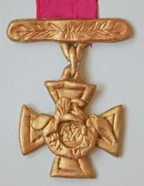
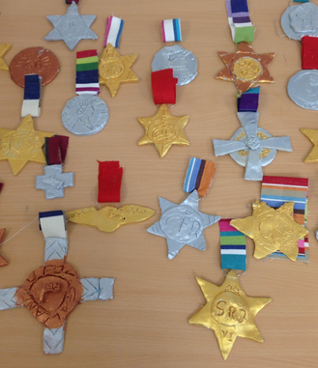
You could try making some salt dough (or card) medals.
1 cup salt
2 cups plain flour
$\frac{3}{4}$ cup of water

You could have lots of fun using different objects to imprint patterns on the dough shapes to give texture to the medals. Air dry or bake in the oven on a very low heat until hard, then decorate once cooled.

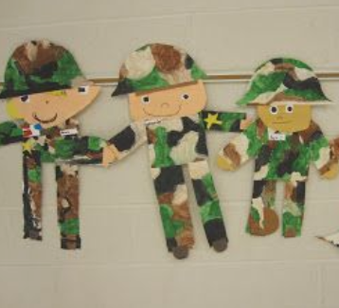
You could make some happy soldiers.
Paint some card in camouflage colours. Once dry, cut out some arms, legs, bodies and hats. Draw some happy faces on a different sheet of card and cut out. Finally, assemble them into little soldiers- you could even add little medals or stars. You could make enough to stick them on to some string to make bunting or a window decoration.

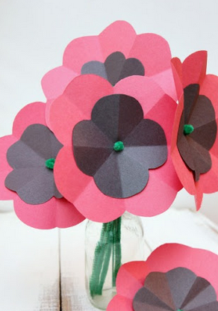
You may wish to have a go at making some poppies.
There are lots of different ways of making these colourful flowers.
You could use coloured paper or card as shown here.
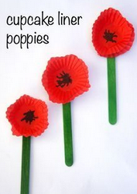
You could use red cupcake cases as shown below with lollypop sticks as stalks.
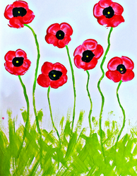
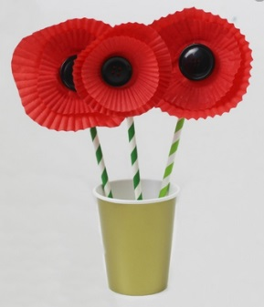
You could paint a picture and add tissue paper poppies to bring it alive.
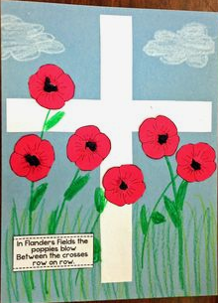

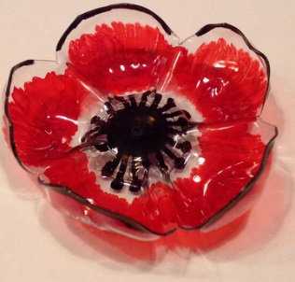
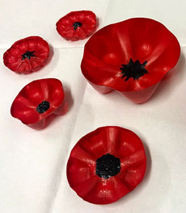
Or you could paint bottle bottoms with acrylic paint and make a hanging mobile – you could also decorate it by adding some beads.

