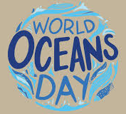
Art - World Oceans Day Poster Challenge
Why do we celebrate World Oceans Day?
There is a multitude of reasons why World Ocean Day is an important event to celebrate. Here are just some of them:
- The ocean generates a lot of the oxygen we breathe.
- It provides food around the world.
- It regulates the climate.
- It gives work opportunities to thousands of people.
- Is home to trillions of fish and sea creatures.

Think about the meaning behind World Oceans Day. This year’s focus is ‘Our Oceans, Our Future’. Create a poster to inform people about the damage that is being done to our oceans and sea creatures. Could you also use positive messages to explain the changes people can make to help our oceans?

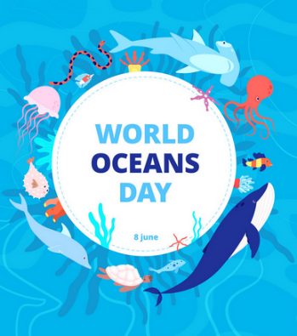
Just some ideas…
