Radio Blogging St Stephens Year 6 Shout Out
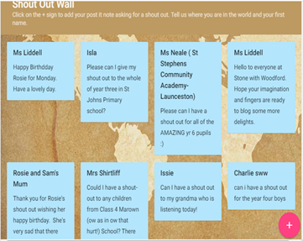
https://radioblogging.net/index.php/category/live-shows/
Listen to today’s with Anthony Horowitz ( 22/5/2020) show and there is a shout out for you at the end of the show

