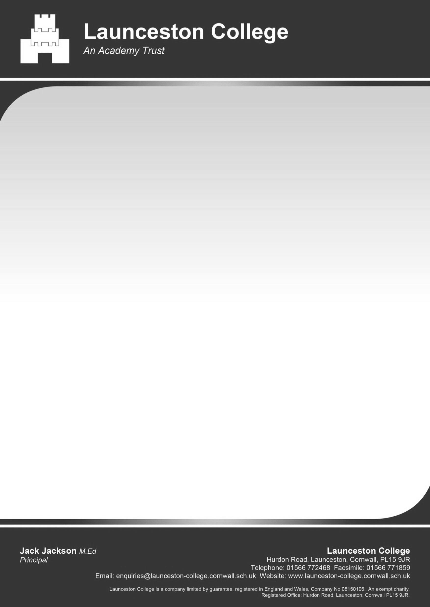

March 2020

Dear Parents/Carers

I wanted to write to you to reassure you about your child’s transition to College in September 2020. We are very much looking forward to them joining us and working with all of you. For now, the way we communicate with you will need to be online and I would urge you and your child to visit the College website where we will start to post transition information and updates to help you prepare.

This term we have been visiting Year 6 students at their primary schools but regrettably some of these visits did not happen due to the closure of the schools. A transcript of the talk I normally give to students is on the website, I hope that you can read this with your child so that they have received the same message as all other students. We will continue to liaise with your child’s teachers so that we have all the information we need to be able to make the transition process as smooth as possible.

We will continue to follow our plan for transition as much as possible and should information change then we will ensure you are briefed via the website. Please can you read the key letters on the website and return your thumbprint recognition slip after Easter and complete the online admission form. This is important information that will help us be ready for your child to start in September.

An update will be released about the Summer School in due course, we still hope to be able to run one as it is so useful in helping students to become familiar with the College, meet new friends and key staff.

I sincerely wish you all the very best at this difficult and unprecedented time. Do keep yourself and your child(ren) safe.

Yours sincerely

****

L.Rash

Assistant Principal KS3 and SENCO

