World Earth Day Activities

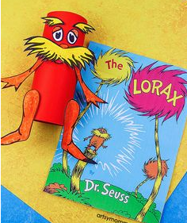

To celebrate **World Earth Day** you could have a go at any (or all) of the following 3D art activities.

I have tried to pick activities that use items you may already have at home – enjoy!

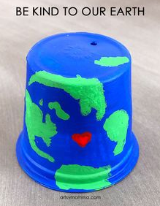

This could easily be made into a bird feeder?

