This week’s Art Challenge – set by Tyler (Y4) A Harpy Eagle
This week Tyler has asked for ideas on how to draw a Harpy Eagle. I couldn’t find many tutorials, but here are the ones I did manage to find. Happy drawing Miss Callcut and Tyler.
Next week: Drew’s Dinosaur challenge
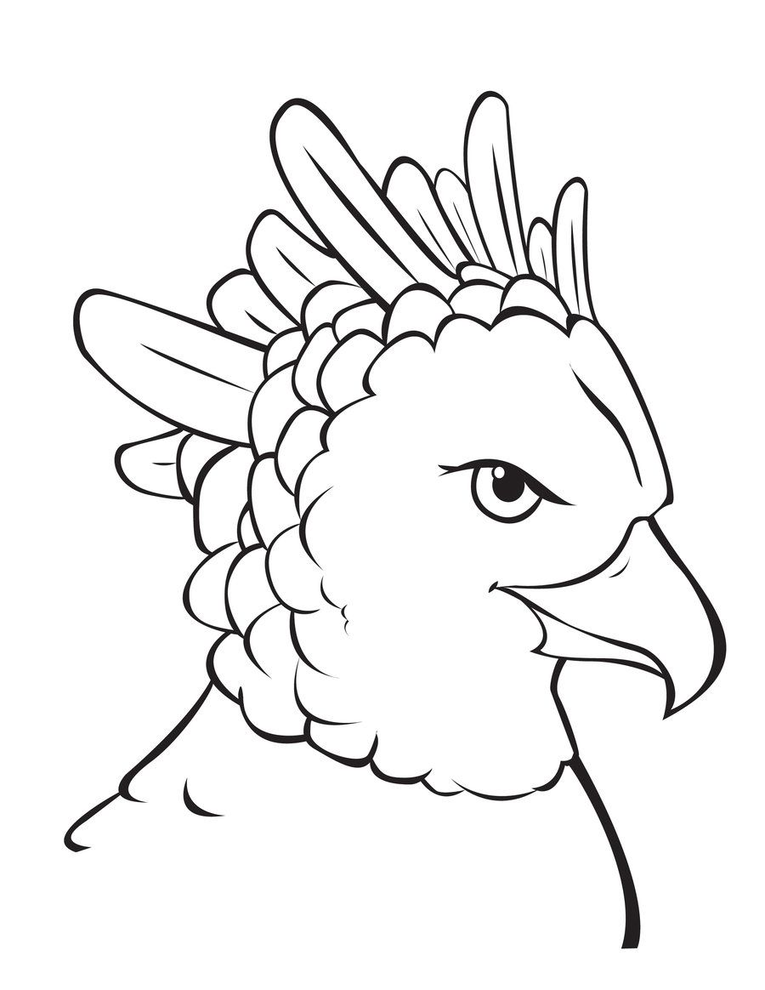
Please upload to J2E so that I can put them on our new Art Gallery page.
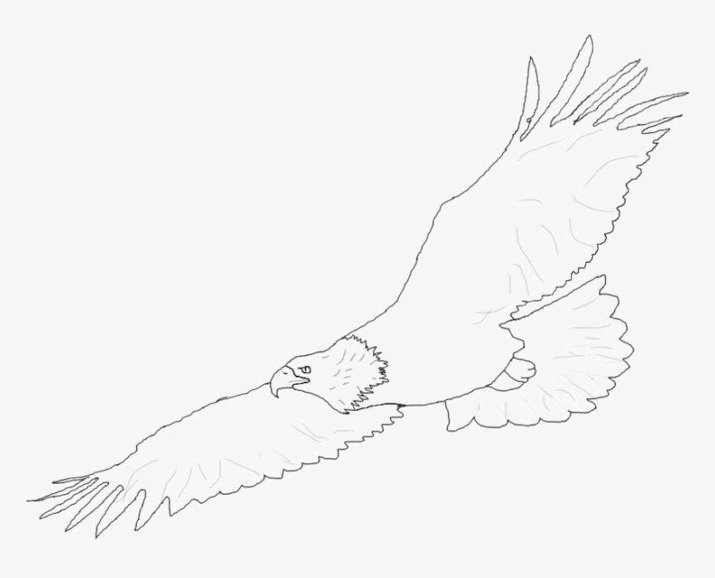
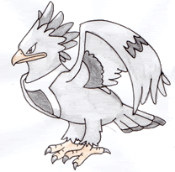
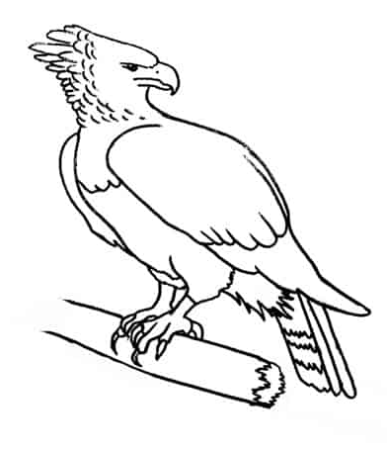

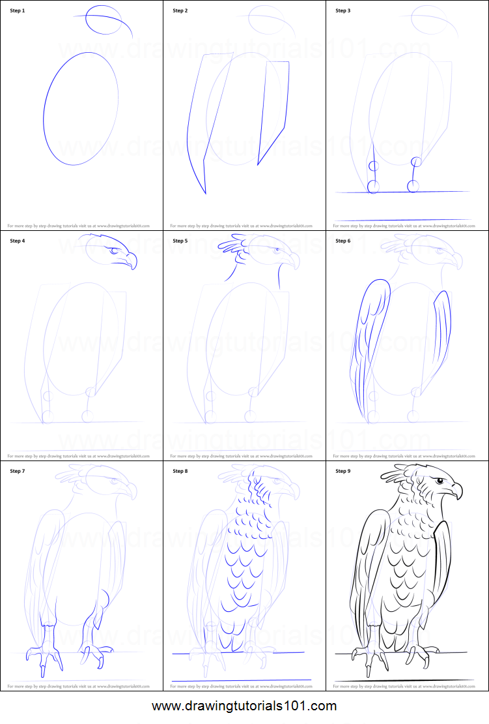
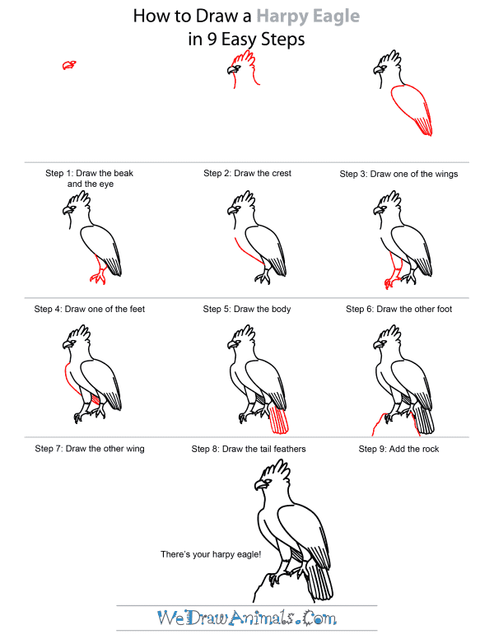

Useful websites:
https://www.youtube.com/watch?v=Ut3U9Yds8I0
https://www.youtube.com/watch?v=58BLxzD1V0U
https://www.youtube.com/watch?v=yMgx6qyH8wA
https://how2drawanimals.com/8-animals/419-draw-harpy-eagle.html?start=2

