This week’s Art Challenge – set by Lucas (Y6) A Dolphin

This week Lucas has requested ideas for how to draw a dolphin…I can’t wait to have a go at a few of these myself! Happy drawing everyone! Miss C… and Lucas
Please upload to J2E so that I can put them on your class blog
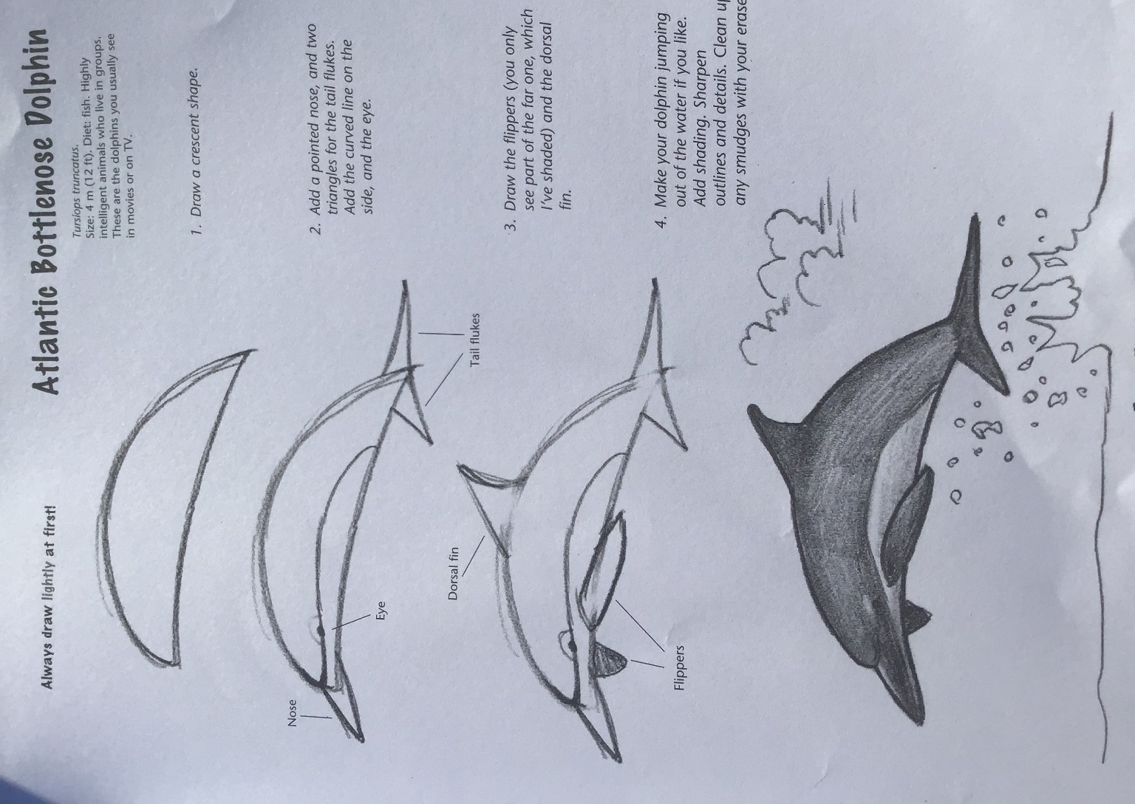
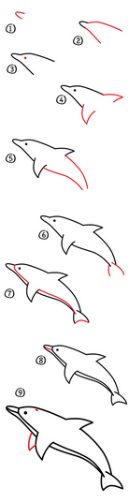
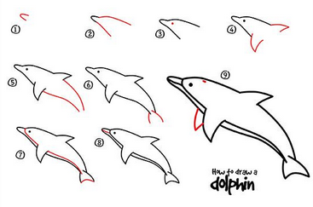
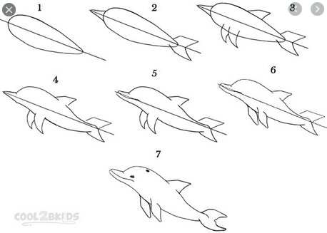
Useful websites: https://www.youtube.com/watch?v=Bu076kN-E50
https://www.wikihow.com/Draw-a-Dolphin

