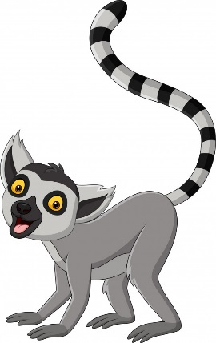
This week’s Art Challenge – set by Tyler (Y4) A Lemur

This week Tyler has requested ideas for how to draw a lemur…I can’t wait to have a go at a few of these with my boys! Happy drawing everyone! Miss C… and Tyler

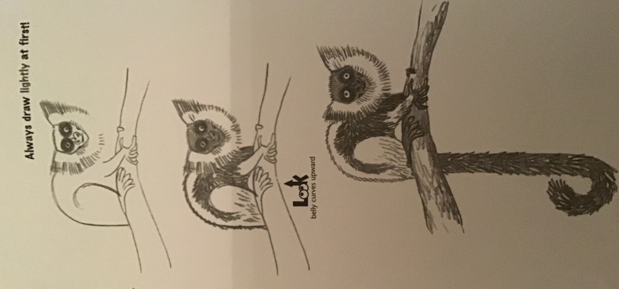
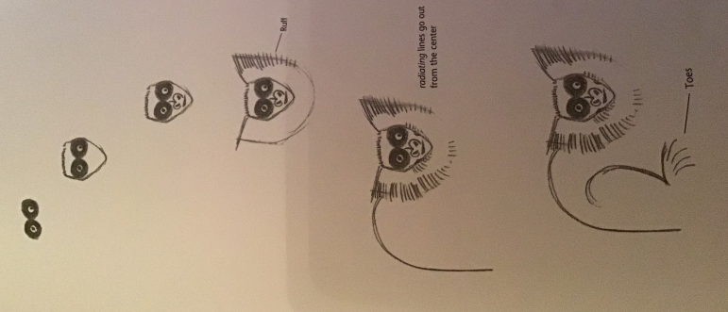

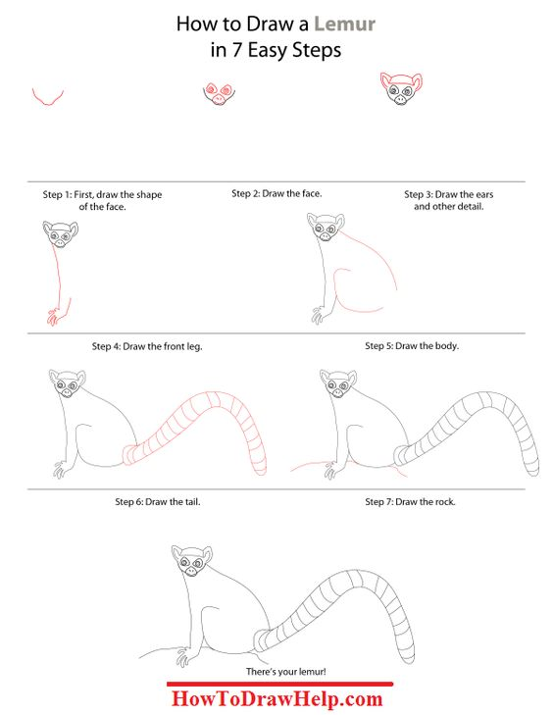
You could always make it ring-tailed lemur by only shading rings on the tail instead of the whole tail

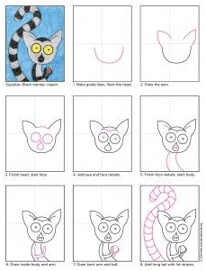
Youtube video of a realistic one – quite tricky?!
https://www.youtube.com/watch?v=Auq75bnnqyU
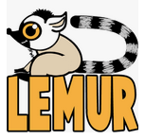
How to Draw a Ring-tailed Lemur
