Year 4 Multiplication check

Key Information:

The national times table check is a test for all year four pupils that takes place between the 6th and 24th of June 2022.

The purpose of the check is to determine whether your child can fluently recall their times tables up to 12, which is essential for future success in mathematics.

It is an on-screen check consisting of 25 times table questions. Your child will be able to answer 3 practice questions before taking the actual check. They will then have 6 seconds to answer each question. On average, the check should take no longer than 5 minutes to complete.

When we receive the results, we will share them with the you and the children. This information will be used to inform our teaching and help provide support for pupils.

Why are Times tables important?

Times tables are fundamental to support children and under pin everything within Maths. It is vital that all children know their multiplication facts up to 12 x 12.
Knowing the multiplication facts up to 12x 12, will give them the essential knowledge needed to be proficient with Years 5 and 6 Curriculum,

How can you support your child at home?

- Encourage children to play Times table Rockstars as often as possible. Small 5 minute daily sessions will help children to learn times tables more than one long session a week. The soundcheck is very similar to the multiplication check.

- Quiz your child at home regularly. This could be when making dinner or on the journey to school

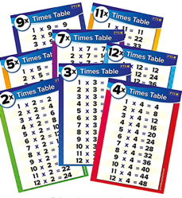
- Display a poster with all of the times tables facts on at home.

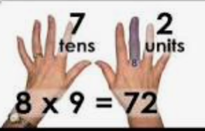
- We teach the children fun tricks at school such as the 9 times table finger trick. If you know this, you can practise it with them at home.

- Create flash cards with your children and let them play with friends, siblings, grandparents. They could write the answer on the back and test themselves.

- We use lots of songs to teach our times tables in school. Children can recognise these from you tube by typing in 4 times table song. Let them sing along with those at home. Children could also make their own times tables.

- Chanting their times table is an excellent way to learn them. They could do this each time they walk up the stairs.

Any times tables practise that the children can do at home will really support them to become proficient in their times tables and help them with their everyday maths learning.

If you require any resources please let us know.

Thank you for your support.

