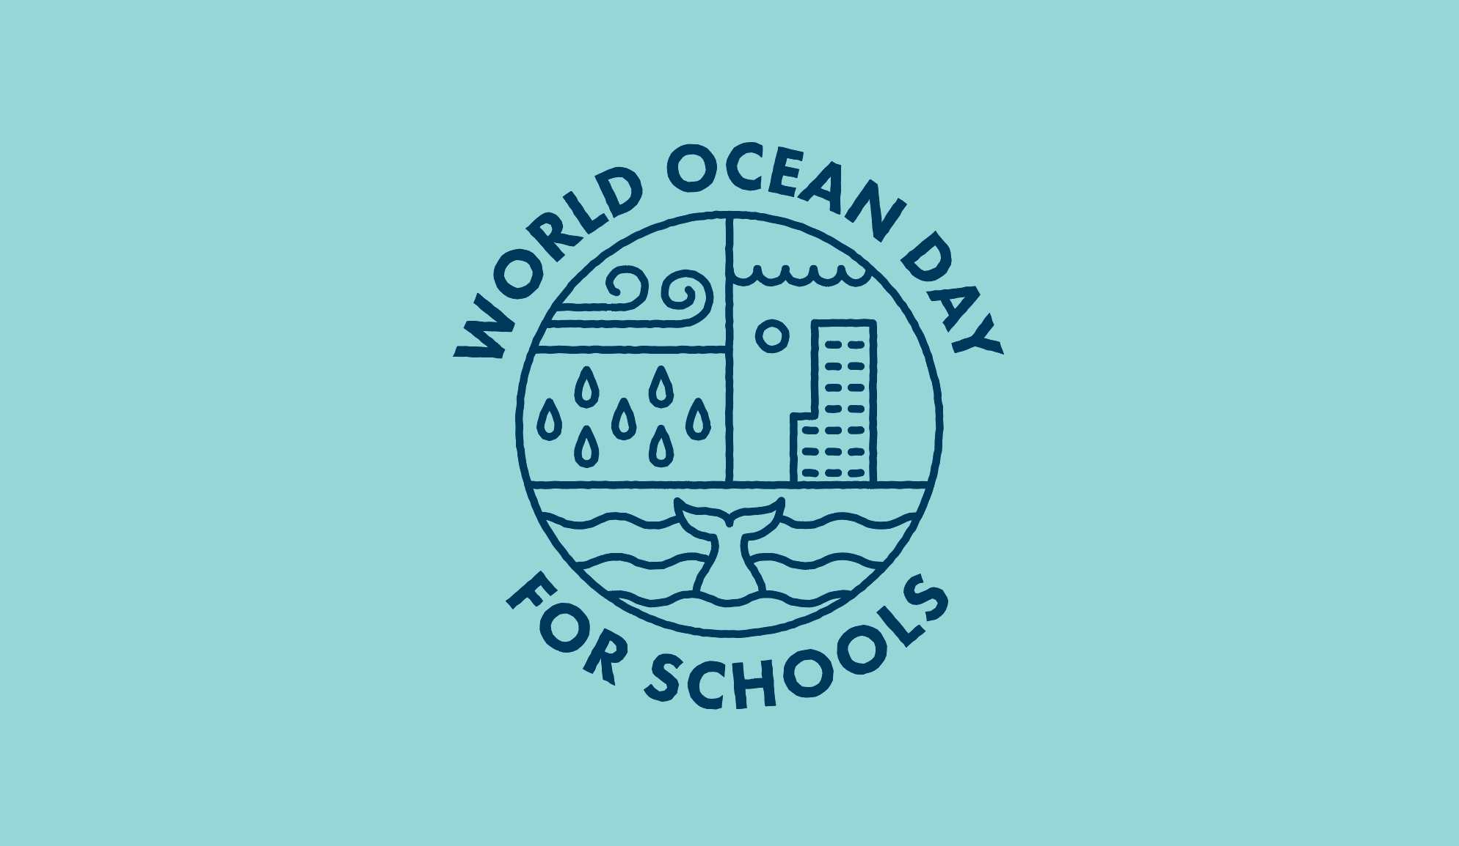
MONDAY 8TH JUNE
… was an important and special day for 100, 000 schools. I wonder if any of our St Stephens community joined with World Ocean Day too. If you did, we would love to hear about it, on J2E!
LEARNERS AND THINKERS
I was very proud of four of our intrepid St Stephens learners, as Skye, Belle, Abigail and Tyler embarked on a day of activities about our global ocean, thinking about some of the many issues that face it. I must say, it gave me hope to think that they are amongst the generations who will have to find solutions to some serious environmental problems.
WILLING TO LEARN
The children showed great awareness of the issue of plastic pollution in our oceans, and more importantly, a willingness to learn more about it. They began by plunging their hands into the cold waters of the Year One water tray, to hunt down and separate plastics and man-made items, from the natural ecosystem!
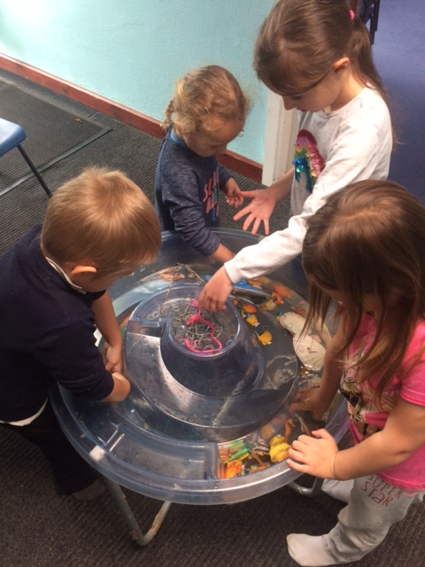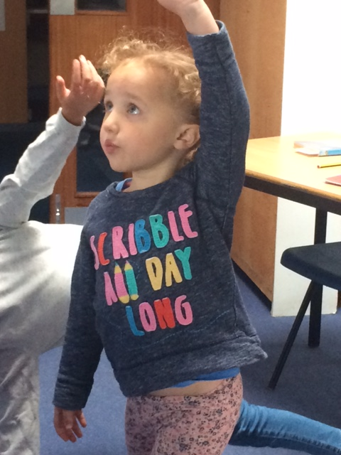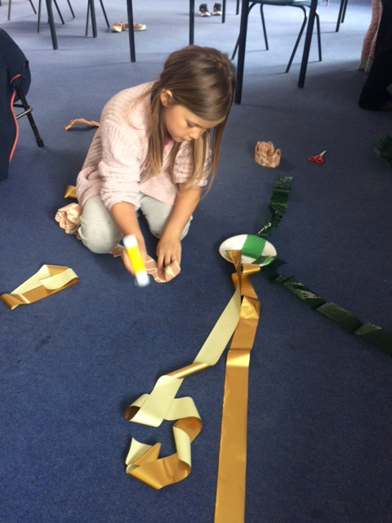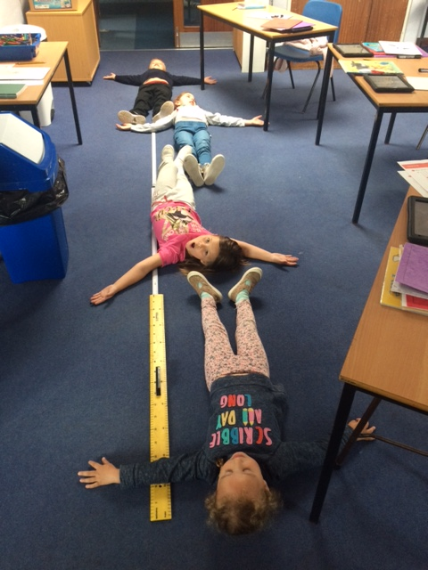
Plastic hunt Surfing Yoga Octo-Jelly Sun Fish fin to fin
ACTIVITIES
… of all sorts were available online throughout the day, and we joined in with surfing yoga, a song with actions and rock pooling with the National Marine Aquarium in Plymouth. We made paper plate jellyfish and octopi – and also one or two previously undiscoverd ocean species! We took a quiz about how people use the sea, learnt about some of the unusual creatures that live in it, and measured out the width of the giant Sun Fish! We had a competition to see who could list the most sea animals in 30seconds, and we played marine snap. Tyler kept winning, and so had a lot of information on his winning cards to read out! We listened to some fantastic online stories over lunch and then spent some time with our feathered friends in the garden area.
After lunch we made sea turtles and decorated beach pebbles. We then looked at the sadder side of how serious the problem of plastic pollution in the sea, really is.
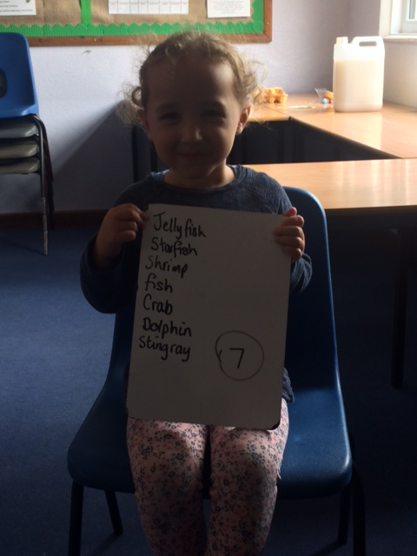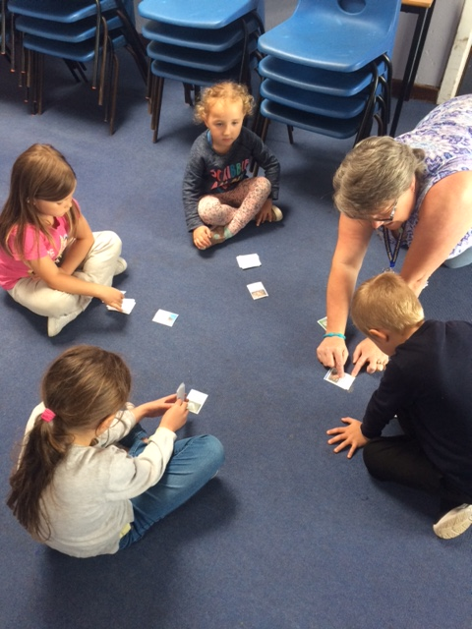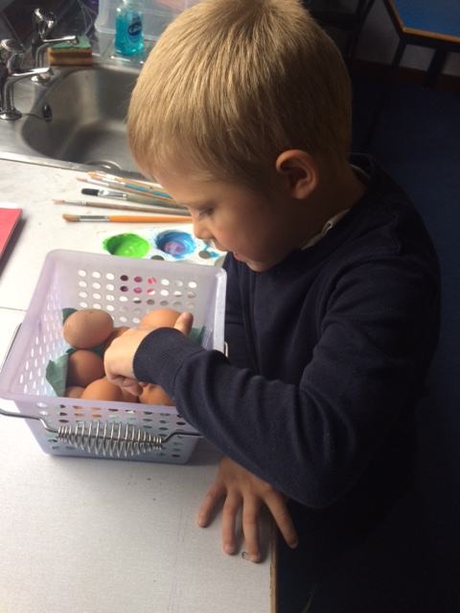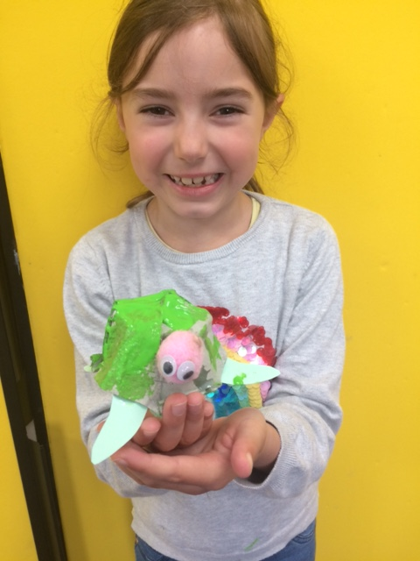
In 30 seconds Marine Snap Count in 2s; share by 4 Sea Turtles
If we had the rest of the week, I know our team could learn still more, and really get to understand why the ocean and its health, matters.
STILL AVAILABLE
… until the end of June on https://worldoceanday.school/ . Many UK and international marine conservation societies, orgnised the programme of online activities, stories, events and talks, which can still be seen. Take time to watch the amazing, short ocean films at the end – they will blow you away!
And F.Y.I., BBC Four showed an excllent programme on the future of the oceans (Ocean Autopsy) and BBC One have been re-running a beautiful series of three films called Ocean Giants : https://www.bbc.co.uk/programmes/m000jy2l
https://www.bbc.co.uk/programmes/b013q4z6
WHAT WE CAN DO
The children thought about this over the course of the day … but they can only do it with the help of the adults. Here is what we thought, plus some extras :
*Buy less plastic and fewer items that are packaged.
*Make sure that plastic is recycled, or stuffed into Eco Bricks.
*Use less energy – lights, fuel.
*Use fewer chemicals eg cleaners, and dispose of unwanted medicines at your local pharmacy.
*Use bar soap not soap from plastic bottles.
*Avoid glitter or products that contain glitter.
*Avoid products that contain micro-beads like body scrubs and face washes.
*Wash synthetic clothes at 30 degrees and pack them tighter to reduce microfibre release.
WELL DONE
… Abi, Skye, Belle and Tyler for being brilliant ocean explorers for World Ocean Day. Photos of your work were sent to https://commonseas.com/, who really loved what you created 😊
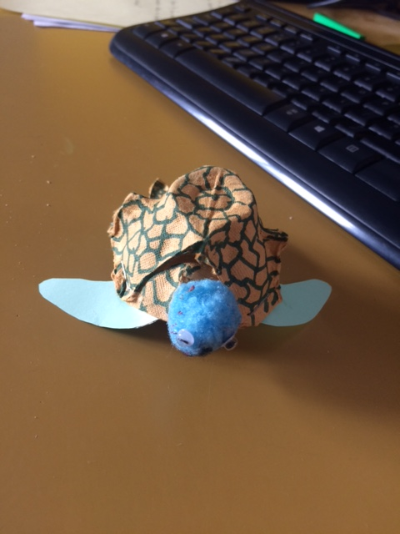
(And let’s not forget Mrs. Cowling’s sea turtle!)

NEXT :
21st June is International Make Music Day.
Look out for events on : https://makemusicday.co.uk/
I particulary recommend looking at the work of BASH THE TRASH – and their great ideas for making decent junk instruments!


