This week’s Art Challenge – set by Cody (Y6) A Panda
This week Cody has asked for ideas on how to draw a Panda. I know there are lots of you out there who love pandas, so I look forward to seeing all your amazing drawings! I have tried to include some real-life examples and some cartoon ones. Happy drawing everyone! Miss Callcut and Cody.
Next week: Amber’s city buildings challenge
Please upload to J2E so that I can put them on our new Art Gallery page.
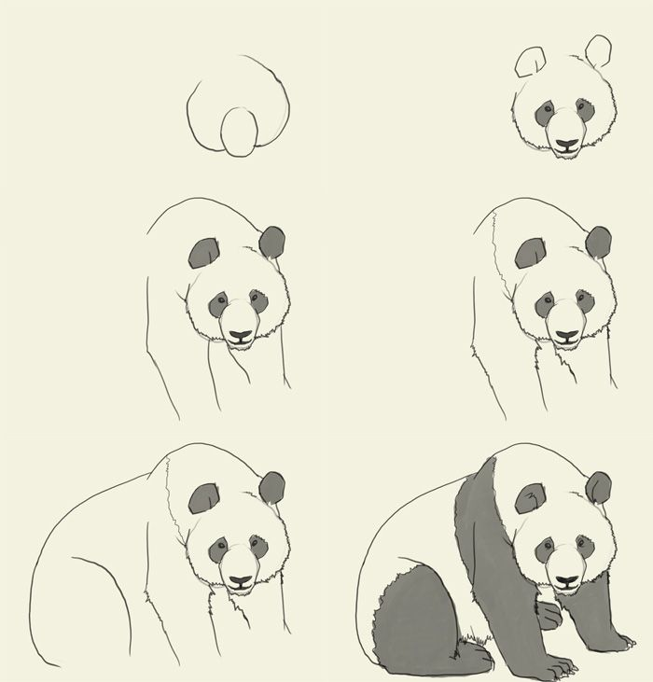

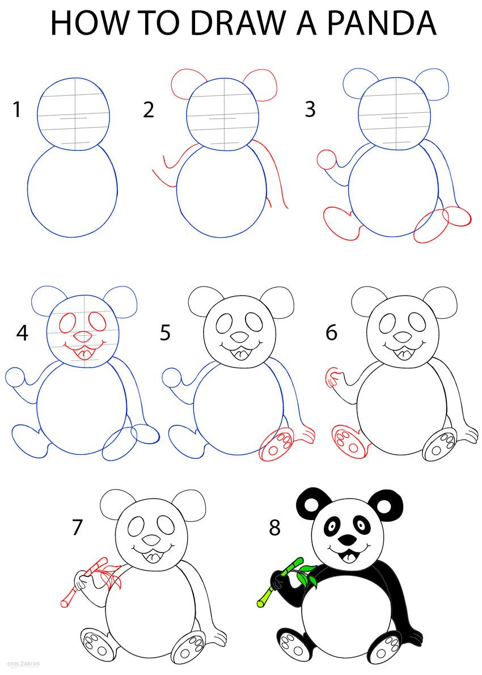
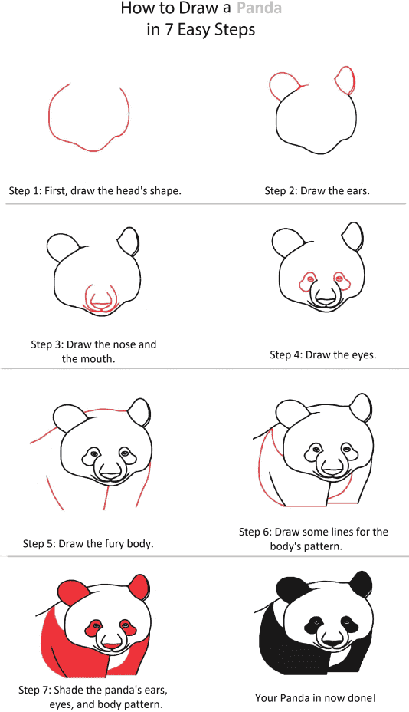

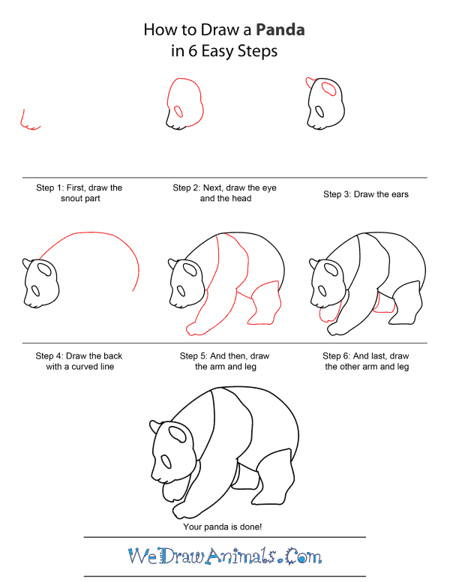

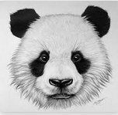

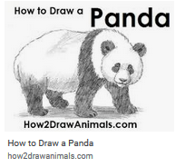
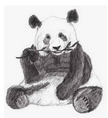
Useful websites:
https://www.youtube.com/watch?v=WGZxwDjHurU
https://www.youtube.com/watch?v=poonEK2bOdI
https://www.youtube.com/watch?v=ojkMsHxC0BU
https://www.youtube.com/watch?v=xu3WUyWXrv0

