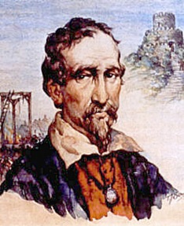
Y6 Local fieldwork – Launceston/Cuthbert Mayne
location | valley | survive | royal
constitutes | central | catholic | guilty
grid reference | ancient | religion | achieve
dominant | route | treason | abolish
settlement | centre | persuade | behead
prisoner | erected | determined | noble
looming | defend | support | necessary
fortified | soldier | controversy | church
remaining | reign | execution | advise

