This week’s Art Challenge – set by Drew (Y5) A velociraptor

Something new! This week Drew (Y5) has requested ideas for how to draw a velociraptor…I can’t wait to have a go at a few of these dinosaurs myself! Happy drawing everyone! Miss C… and Drew
Please upload to J2E so that I can put them on your class blog

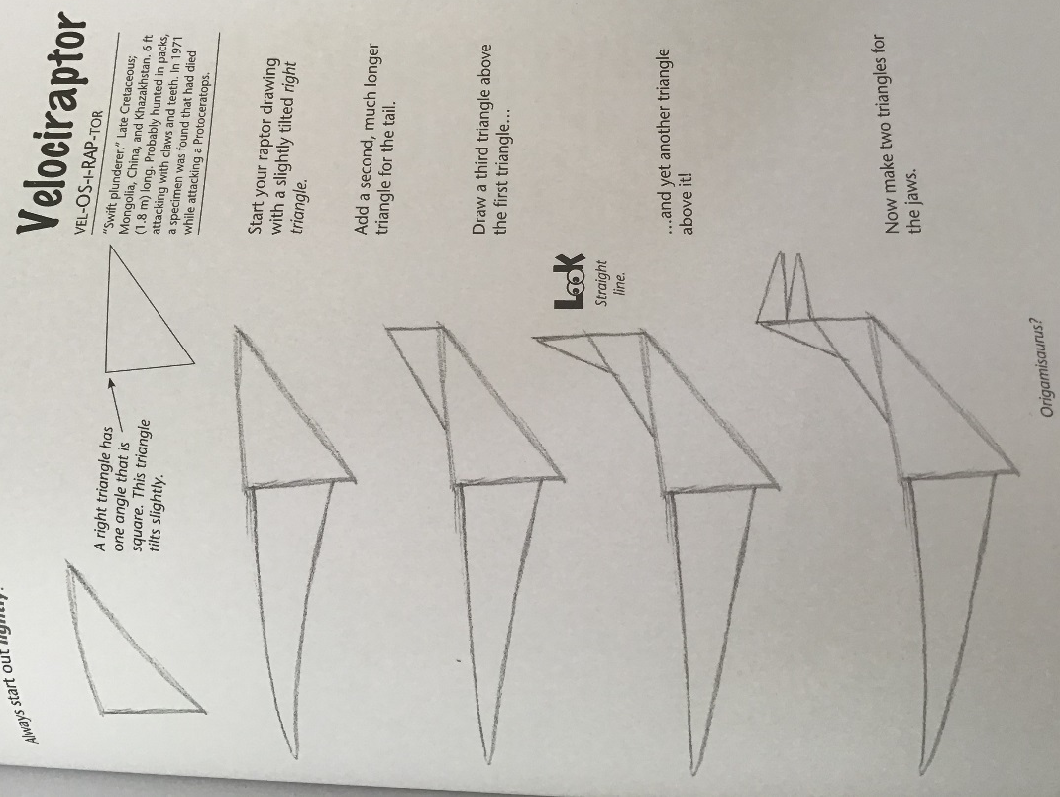
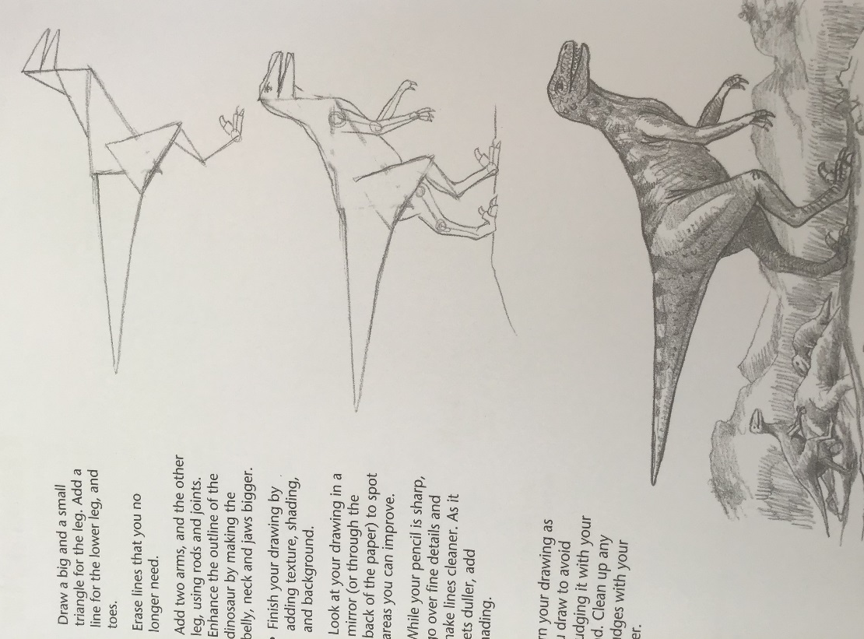
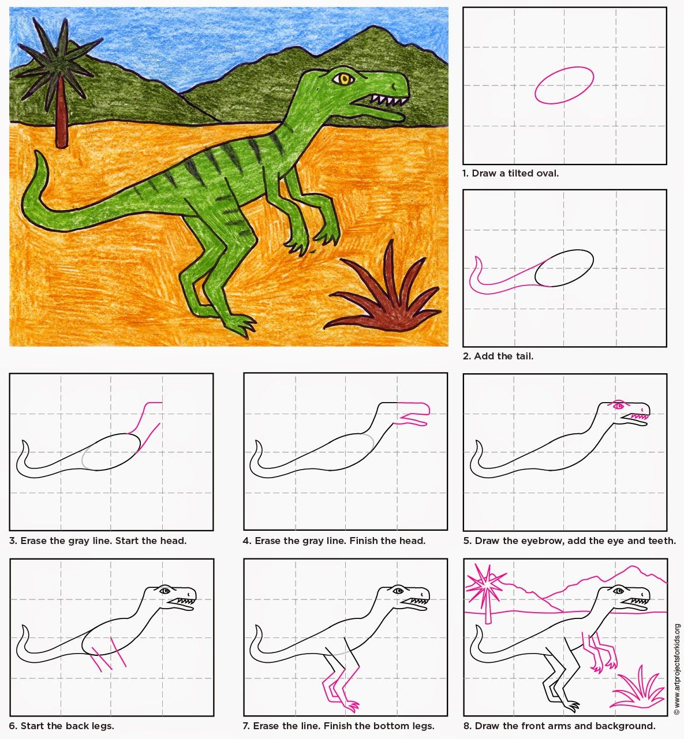
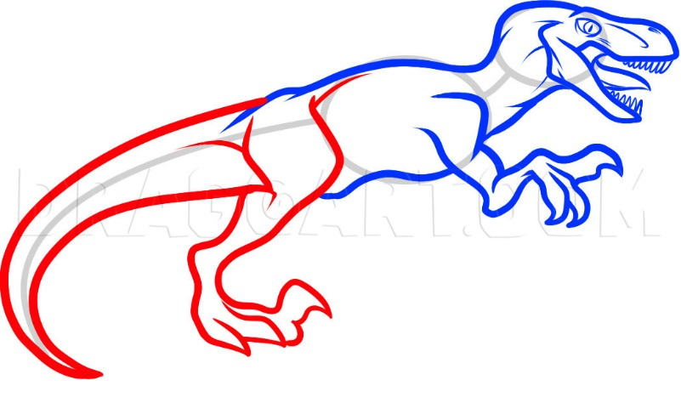
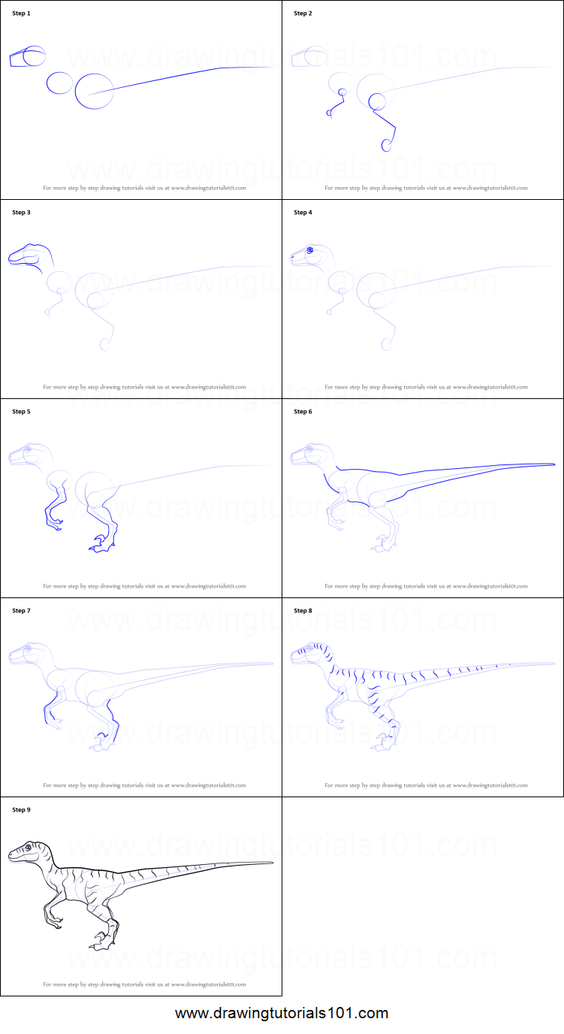
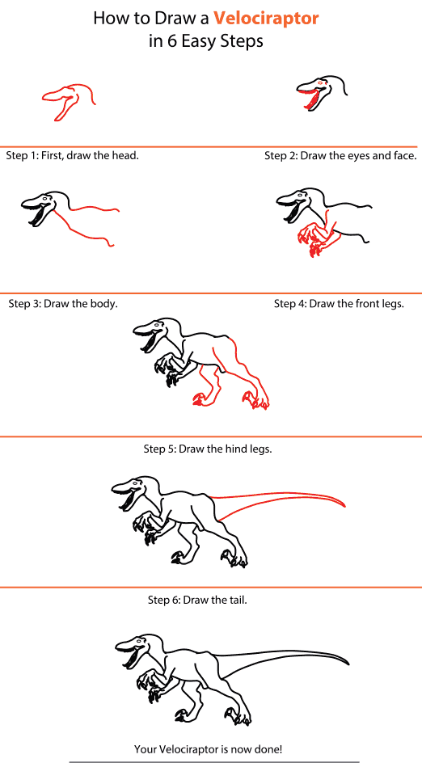

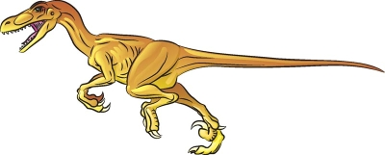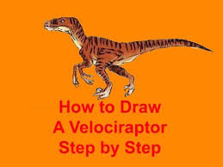
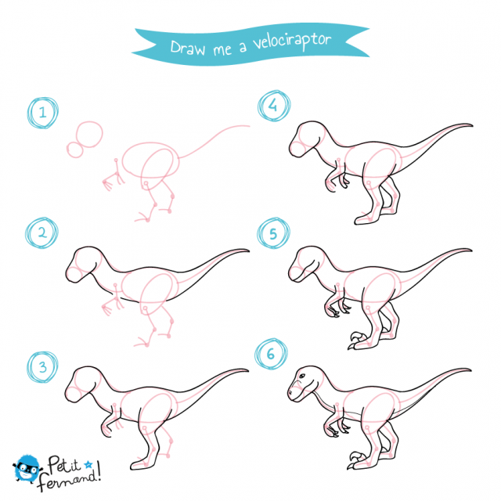

https://www.youtube.com/watch?v=wQGH9-dkpxg
https://dragoart.com/tut/how-to-draw-a-velociraptor-dinosaur-173
https://www.youtube.com/watch?v=mQa7p_Rl_lo
Easier : https://www.youtube.com/watch?v=JaCmlwoLWQ0
This guy is great for lots of different:
https://www.youtube.com/watch?v=9fhy7X-8Los

