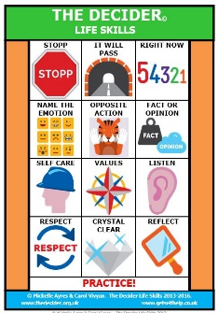
The Decider © Skills are strategies developed by CBT therapists Michelle Ayres and Carol Vivyan to support mental health. They are 12 useful CBT and DBT informed life skills that we have been teaching to class 2 and 3 to help the students to manage their emotions and impulsivity when things are difficult. Class 2 are learning 4 skills whilst class 3 are doing all 12. CBT focuses on how thoughts, feelings and emotions are all interlinked. The classes really enjoy the sessions and we are sharing their learning each week with the school community via the newsletter.

The “Fizz” (a play on words to recognise the physical signs of feeling emotions) is key to the Decider ©Skills and is the first thing that the students have learned about. By understanding when we are feeling “the fizz” we can choose what to do, rather than acting impulsively without thinking. The positive results from choosing an action will usually make for a better outcome (as if we act on impulse when we feel the fizz, the results can often be unhelpful).
When we are growing up, we experience all kinds of emotions as we develop and try to make sense of the world. Thoughts and emotions can be overwhelming (this is normal) and recognising them is important to being able to understand ourselves. Symptoms of feeling the fizz (freeze, flight, fight, flop) can include, our brains feeling highjacked (finding it hard to think clearly), dry mouth, eyes widen, body sweats, digestion slows, heart beats fast, tense muscles, pain, adrenaline release. Sometimes the body can flop in response to the strong feelings that are being experienced, and the students explored the different signs/things that they may experience when they are feeling the fizz, using a fizz scale from 0-10.

The first Decider © Skill is STOPP.
When we are feeling the fizz we STOPP to give ourselves a chance to use our skills.

S- Stop (do not act immediately – pause)
T- Take a breath – one long breath in through the nose and out through the mouth
O – Observe – what am I thinking? What’s going on for me? What am I reacting to? What number on the fizz scale am i?
P – Pull back – Zoom out, have a look at the bigger picture. Is there another way to look at what’s going on? What advise would I give a friend in this situation?
P – practice (what works) and proceed only when you are sure what the best thing to do is.
The Decider © – IT WILL PASS SKILL
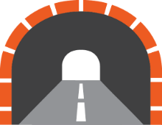
When we are feeling upset about a situation, we may feel the urge to escape, hide or run away from it.
It can help to imagine that we are going through a long tunnel. Stopping and turning around or trying to escape will not help– we just have to keep on going. The emotion will pass.
When we are upset, we cannot change a situation, so we have to go along with it and remind ourselves that “it will pass”. Just like being on a ferry crossing a rough sea, the storm will pass, we will sail on and reach a calm harbour. The emotion will pass.

The Decider © Skills – RIGHT NOW 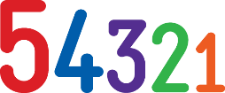
When we are feeling the fizz we need to use a skill that can help us straight away. Using our 5 senses can help us do something RIGHT NOW to help improve the moment.
Right Now is a grounding technique and it helps to change our focus and attention.
5 | Things I can see right now (or imagine I can see right now)
4 | Things I can hear right now (or imagine I can hear right now)
3 | Things I can touch right now (or imagine I can touch right now)
2 | Things I can smell or taste right now (or imagine I can)
1 | Deep slow breath  Then simply focus on your breathing…. In this moment… now

The Decider © Skills – NAME THE EMOTION
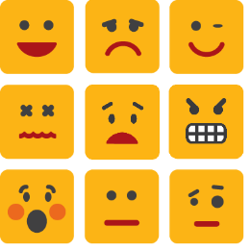
We all experience emotions, and when we are distressed, it can feel like our brains have been hijacked and we cannot think straight, and the distress can feel overwhelming.
Every emotion carries an urge to act, so the next time you feel an emotion, name it first so that you can decide what to do before acting on the urge. Naming the emotion helps us to identify what we are feeling and then chose to react positively.

Decider Skills ©– OPPOSITE ACTION
When we feel the fizz we have powerful physical sensations in our bodies that give us the urge to act. Emotion can cause us to respond physically and impulsively.
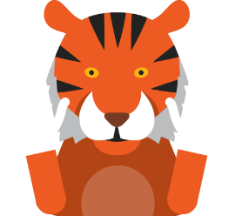
Tigers react to a perceived threat by attacking. If a tiger noticed how it was feeling, and the urge to attack they would respond by walking away or approaching quietly.

Opposite action encourages us to do the opposite of the emotional urge to react.
“If you always do what you always did, you will always get what you always got”.
Emotion | Action urge (Old reaction) | Opposite action (New reaction)
Sad | Withdraw | - Do something  - Go out  - Be with others
Anger | Attack | - Gently avoid  - Be kind
Fear | Hide | - Don’t hide – be open

Decider © Skills – FACT OR OPINION
When we are feeling the fizz our emotions often power our opinions, and our opinions reinforce our emotions to make us fizz even more!! It is a vicious cycle that can be very powerful and can lead us to act on impulse with unhelpful consequences.
If a friend walked past without saying “hello” we might think “she ignored me” or “she didn’t see me”. Our opinion will then affect our emotion. The only fact is that the person walked past – anything else is just opinion (our own way of trying to make sense of what just happened). The reality or fact may be very different.
FACT: Evidence to support, no argument, driven by rational thoughts, would stand up in court
OPINION: Based on our own beliefs, it could change, driven by our emotions.
In times of distress, it can therefore be helpful to ask ourselves whether what we are thinking is FACT or OPINION so that we can chose how to respond

Decider © Skills – SELF CARE
Looking after ourselves is our own responsibility and we need to work at looking after our health, keeping healthy and treating illnesses if we become unwell. As children our parents or carers look after us, but as we become older and more independent it becomes our job to look after ourselves.
Self-care practiced every day helps to protect us from emotional pain when it occurs and strengthens us to cope. The image that we use with The Decider is a helmet -as just as builders wear a helmet to work to protect themselves, we need to practice self-care.
S-E-L-F reminds us of what we need to do regularly to keep our minds and body health. Just like a battery we need to keep ourselves charged by doing things that make us feel good.
S – SLEEP
E – Eating and Exercise
L – Look at – illnesses, challenges (transitions to secondary school, exams, life events)
F - Find Fun in every day – do something that gives you joy, a connection with others or a sense of achievement.
Making a plan every day helps us to balance work/school rest and play.

Decider © Skills – VALUES
Our values are the things that matter to us. They give us direction for where we want to go in life and help us decide on our goals. Knowing and understanding our values helps us to make life decisions and gives us purpose.
We use a compass to navigate around the world and we use our values to navigate through our lives. For example, if my life value is healthy eating my goals might include eating 5 fruit and veg a day. If I then eat 5 chocolate bars or packets of crisps my internal compass will tell me that this does not fit in with my values and I might not feel great about myself – but understanding my values will help me to cope with this.
Some examples are:
Life Value | Not at all important to me | Quite important | Very important | A must!
Relationships friendships/Family
Achievements /school
Enjoyment /leisure

At times of distress, knowing our values can help us decide what direction to take.
Decider © Skills – LISTEN
Listening is a really valuable skill. It can help to remember that we have 2 ears and one mouth – so we need to listen more than we speak.
Listen is an acronym of silent – which can help to remind us that we need to be silent to listen.
Not being distracted and paying attention to what others are saying is important to avoid misunderstandings and mistakes. And it’s nice to be listened to – it helps us to feel valued!
Ways to actively listen include:
- Nodding
- Eye contact
- Leaning in
- Smiling
- Showing interest
- Waiting until someone has finished talking before asking questions or interrupting

Decider© Skills – RESPECT
Respect is about valuing other people as well as ourselves and treating others how we would like to be treated.
Respect demonstrates positive feelings and kind regard for us, other people, places, animals, property, cultures, values and qualities.
It is important to show RESPECT even at times when we don’t feel like it.
Give respect Get respect
Think of a person you respect – what qualities do that have that you like?
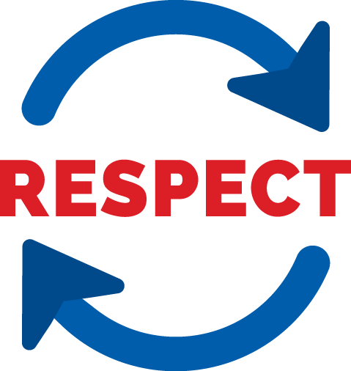
R – Respect self and others
E – Equality and esteem
S – Saying please and thank you and sorry
P – Polite, kind and considerate
E -Ears to listen
C – Clear and Calm communication
T - Treat others how you want to be treated
Decider © Skills – CRYSTAL CLEAR
This skill is useful when we need to make ourselves heard and understood by communicating in a clear and concise way. We need to remember to recognise that we need to communicate what we need people to know & not just give hints – after all, people are not mind readers!!
This also applies to saying “no” which many of us find hard to do. If we say “yes” when we really mean “no” this can create difficulties later on.
C – Concise – a short summary of what’s going on
L – Logical -making sense
E – Emotion free expression of feelings and opinions (without blaming)
A – Assertive (& thinking about Alternatives)
R – Realistic (& repeat if you need to)
Crystal Clear helps us to get our message across clearly.

The Decider © Skills – REFLECT
We have the ability to look back at things that we do and say so that we can learn from our experiences and make changes for the future. We need to be able to examine our mistakes and also celebrate our successes.
Admitting our failures and difficulties without blaming others or complaining about how we have been treated can be hard but doing so helps us to develop into independent and responsible people.
- When reflecting on a situation ask yourself:
- When I think about what happened, what was helpful and what was unhelpful?
- Is there anything I could change to prevent it from happening again?
- What did I do well? What could I improve
- If it happens again, what would I do differently?
“If you always do what you always did, you’ll always get what you always got!”
Reflect skills helps us to learn from our experiences and make positive changes.

