WHAT IS BIKEABILITY? Bikeability is the national cycle training programme supported and funded by the Department for Transport. The course builds the skills and confidence of children who can already ride. Bikeability cannot only make children better cyclists; potentially for the rest of their lives but can help with general confidence and independent thinking. All of our Bikeability training is delivered by qualified, professional, DBS checked National Standard Instructors. Visit www.bikeability.org.uk for more information

Covid-19: The Bikeability delivery guides that all registered Bikeability providers and instructors must follow were updated on 17th May 2021 in line with current government guidance for schools on implementing Covid-19 protective measures issued on 17th May 2021.
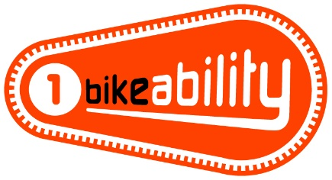 | The Bikeability Level 1 course helps children get more skilled and confident in riding their bikes in the playground and get them ready for cycling on the road. Riders must be able to ride a bike - pedal and freewheel- to participate in this level.
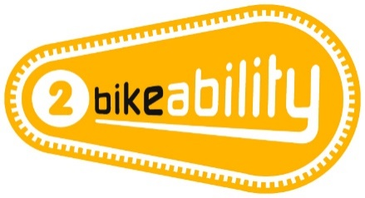 | The Bikeability Level 2 course aims to improve riders’ skills and confidence for cycling on smaller roads and simple junctions without too much traffic. It prepares riders for cycling on larger and busier roads and more complicated junctions. All the riders will have to show the instructors they can do everything at Bikeability Level 1 before they can go on the roads.
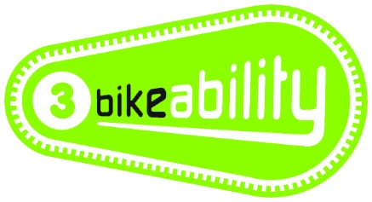 | The Bikeability Level 3 course aims to develop riders’ skills and confidence so they can ride in some everyday road environments, including busy roads and complex junctions. Riders must have achieved everything at Bikeability Level 2 before moving onto the Bikeability Level 3 course.

COURSE INFORMATION | WHAT WILL YOUR CHILD NEED?
Bikeability Level (s) – 1/2  Number of sessions – 2 sessions over the following dates  Dates – 30th Sept, 6th and 7th October.  Year groups – 6  Timing – 9-12 or 1-3  Cost – Free | - A complete consent form (see section overleaf)  - A roadworthy bike without stabilisers  (see checklist overleaf)  - A helmet if required  - Suitable clothing for the weather conditions

FURTHER INFORMATION FOR PARENTS This course develops the cycling skills and confidence of children who can already cycle. Please ask your school about Bikeability Balance and Bikeability Learn to Ride if your child can’t already cycle. To benefit from Bikeability, your child must attend every session and practise what they learn after training. Bikeability skills and confidence will be lost without regular cycling. Bikeability engenders enthusiasm while building skills and confidence to cycle more safely, more often. Please support and encourage your child to continue cycling after training.

HOW TO BOOK Bikeability places are limited and places will be booked on a first come basis. Please complete and return a consent form (see overleaf) to school as soon as possible.

GET READY (Visit bikeability.org.uk/bikeability-training/get-ready/ for more information) Before your course it is really important to have a few things sorted including:

Your bike - make sure you check that your bike is in good working order, with the tyres inflated and the moving parts working well. If you need to take it to a bike shop before-hand, don’t leave it to the last minute!

Your helmet - your helmet should sit on top of your head comfortably, (not too tight or too loose), with the peak sitting about two fingers width from your eyebrows.
The side adjusters should sit just below your ears forming a nice V on the side of your head, and the chin strap should allow for two fingers to fit between it and your chin.

Your clothing - wear whatever you would normally wear to school, but you must also be prepared for the weather. On cold or wet days, make sure that you have your coat and gloves, and an extra layer or two. With a change of clothes available, just in case. On warm sunny days make sure you have put on a good amount of sun cream at the start of the day and keep drinking water throughout the day. And a top tip – as you will be using a bit more energy than normal bring an extra snack, also making sure you’ve had a good breakfast before school.

PRE-COURSE BIKE SAFETY CHECK
Visit bikeability.org.uk/bikeability-training/get-ready/

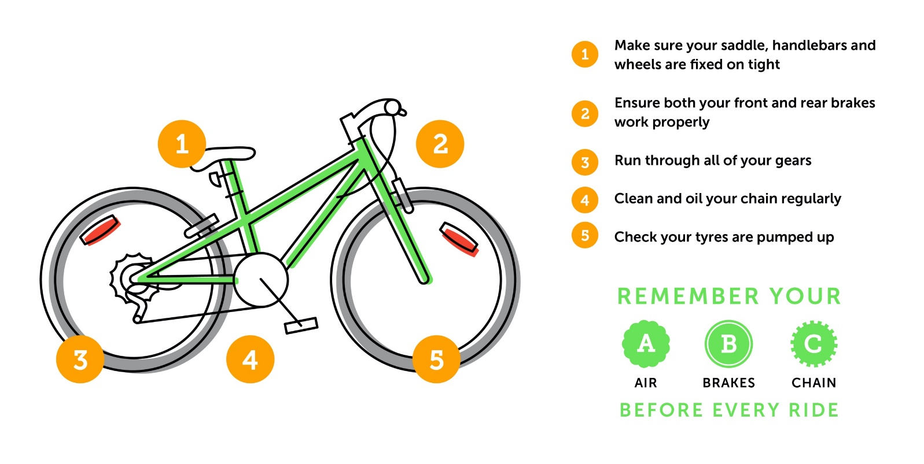

PARENT/CARER - Please read the following information before completing and returning the consent slip to your child’s school. I understand that:
- I agree to my son/daughter taking part in cycle training
- My son/daughter can already ride (may be refused if not)
- The instructors may refuse to train my child if they deem his/her cycle to be un-roadworthy
- It remains my responsibility to ensure my child does not ride an un-roadworthy bike and if I am in doubt as to whether a cycle is roadworthy I should seek the advice of a professional mechanic
- Instructors may at any time refuse to continue to train my child if his/her behaviour or cycling ability is deemed unsuitable
- Arena will not be responsible for any injury or disease transmission or liable for any loss or damage to participant’s cycles and other belongings
- I agree for my child to wear a helmet, which I will provide
- I consent to the Bikeability instructor ‘adjusting’ my child’s helmet if required, however I confirm they are not responsible for the physical condition or appropriate fitting of the helmet
- I understand that pupil data collected will be used to support the delivery and monitoring of training sessions/courses, see bikeability.org.uk/privacy-statement/ for further details.
- I consent to my child using a roadworthy bike provided by their instructor (Level 3 ONLY)
- I agree to encourage my child to practice between each session and after the completion of training

Full Name of Child:
School:
School Year:
Are there any medical/educational needs we need to be aware of, including allergy to hand sanitiser?
Is your child ‘clinically vulnerable’ and at ‘moderate risk’ from Covid-19 according to current NHS guidance?
Does your child live with someone who is ‘clinically vulnerable’ or ‘clinically extremely vulnerable’ from Covid-19 according to current NHS guidance?
To take part in Level 2 training your child MUST be able to do the following tasks.
To help us assess your child’s training needs, please tell us if your child can already do the following without stabilisers or assistance:
• Look behind while pedalling in a straight line
• Pedal one handed in a straight line (both hands)

If you are happy for your child to be photographed and/or filmed to help promote Bikeability, please tick here

I confirm that I have read all the information enclosed and in the ‘Parental Consent Form’ and consent to my child (or the above child for whom I take responsibility) to take cycling lessons and related activities, which may include cycle maintenance as well as riding on the public highway. I understand that this information is retained by my child’s school and used to ensure my child is eligible to undertake Bikeability training

Signed (parent/guardian) :
Date:

